**Visualizing Africa's Economic and Banking Crises: Exploratory Data Analysis from 1860 to 2014**

DSCI 590 - Data Visualization

**Final Project Report**

**Team members**

Yashada Nikam (2001103091)

Aditya Mhaske (2001059030)

Guide: Prof. Yong-Yeol (YY) Ahn

December 8, 2023

**Abstract**

This project, "Visualizing Africa's Economic and Banking Crises: Exploratory Data Analysis from 1860 to 2014," looks into the details of Banking, Debt, Financial, Inflation, and Systemic Crises in 13 African countries. Over more than a century, from 1860 to 2014, the study understands the economy of nations like Algeria, Angola, Central African Republic, Ivory Coast, Egypt, Kenya, Mauritius, Morocco, Nigeria, South Africa, Tunisia, Zambia, and Zimbabwe. The project starts by looking at a big dataset with important info like systemic crises, exchange rates, debt defaults, inflation rates, and more. It gives us useful insights into their financial stability.

Using data visualization and analysis, we want to study patterns, trends, and connections in the dataset. By showing these past economic events visually, we want to answer important questions about what causes economic crises and what they mean. Are there common things in countries that had crises? How does inflation affect these crises? How has banking stability changed? Using data science tools, this project helps us understand past economic problems and gives us a base to know more about Africa's financial history. The things we find and show will help us understand the continent's financial history better. They could also help with making decisions about policies and strategies for the economy in the future, aiming for stability and growth.

**Contents**

| **No.** | | **Name** | **Page No.** |
| --- | --- | --- | --- |
| **1** |  | **Introduction** | **3** |
|  | 1.1 | Importance and Relevance | 3 |
|  | 1.2 | Motivation | 3 |
|  | 1.3 | Background | 4 |
|  | 1.4 | Literature Review | 5 |
|  | 1.5 | Objectives | 8 |
| **2** |  | **Process** | 9 |
|  | 2.1 | Dataset information and Existing Work | 9 |
|  | 2.2 | Ideas and Prototypes | 11 |
|  | 2.3 | Visualization Methods and Selection | 12 |
|  | 2.4 | Count Plot | 14 |
|  | 2.5 | Bar Plot | 16 |
|  | 2.6 | Donut Plot | 20 |
|  | 2.7 | Time Series | 24 |
|  | 2.8 | Map Visualizations | 29 |
| **3** |  | **Results** | 34 |
|  | 3.1 | Relation between Exchange Rates and Currency Crises | 35 |
|  | 3.2 | Relation between Inflation Rates and Systemic Crises | 36 |
|  | 3.3 | Summary of Findings | 37 |
| **4** |  | **Conclusion, Discussion, and Future Work** | 38 |
|  | 4.1 | Research Question Recap | 39 |
|  | 4.2 | Effectiveness and future work | 40 |
| **5** |  | **References** | 41 |

**1. Introduction**

The project, titled "Visualizing Africa's Economic and Banking Crises: Exploratory Data Analysis from 1860 to 2014," dives deep into the economic history of 13 African countries over more than a century. The dataset zooms in on Banking, Debt, Financial, Inflation, and Systemic Crises. Here, we'll look at why the project is important, who it matters to, and what inspires it from existing visualizations.

Understanding Africa's economic history is interesting historically and has relevance today. The economic health of African countries affects not only their people but also global consequences. For investors worldwide, knowing about the economic conditions of African nations is vital. Economic crises in Africa can impact global markets and trade, making it important for the world to pay attention to what this project discovers (Yakubu, 2019; Yakubu & Bunyaminu, 2022).

**1.1 Importance and Relevance:**

This project adds to our understanding of Africa's economic history, pointing out key events that have shaped the continent's economic path (Daumont, 2004; Caprio & Klingebiel, 2002; Lindgren et al., 1996). By looking at crises in Banking, Debt, Financial, Inflation, and Systemic areas, we aim to give useful insights into what has influenced economic ups and downs in these countries (Xiong, 2008).

In a time where decisions based on data are crucial, the project's findings and visuals can be practical. Policymakers, government bodies, international groups, and businesses in Africa can use these insights to create strategies that help handle economic issues and keep things stable (Inoue & Hamori, 2016; Jajah et al., 2022; Yakubu, 2019; Yakubu & Bunyaminu, 2022). Plus, educators and researchers can use the data and visuals as tools for learning and as references for more academic exploration (Bashiru et al., 2023).

**1.2 Motivation**

This project is motivated by a keen interest in grasping Africa's economic history, particularly regarding banking, debt, finances, inflation, and systemic crises.

* Historical Context: Africa's history is rich and intricate, marked by economic highs and lows. Exploring historical data spanning over a century provides valuable insights into the continent's economic challenges and successes, crucial for informed decision-making today and future planning.
* Policy Implications: Economic crises profoundly impact a nation's citizens. Governments and policymakers need data-driven insights to create strategies to mitigate future crises and foster economic stability. This project aims to lay the groundwork for evidence-based policymaking.
* Global Relevance: In our interconnected world, the stability of any region's economy ripples beyond its borders. Africa's economic performance affects global markets and international relations. A thorough analysis of economic crises in Africa contributes to a broader understanding of global economic dynamics.
* Data-Driven Decision-Making: In the age of big data, utilizing data is crucial. This project employs data science techniques to uncover meaningful patterns from extensive datasets. The gained insights can empower businesses, organizations, and governments to make informed decisions for the benefit of society.
* Educational Value: Beyond practical applications, this project holds significant educational value. It serves as a valuable resource for researchers, students, and anyone interested in African economic history. The project's findings and visualizations can enhance the understanding of economic concepts and historical trends in academic settings.

**1.3 Background**

Africa's economic journey, characterized by banking, debt, financial, inflation, and systemic crises over a century, is both a story of successes and hurdles. Thirteen African countries, including Algeria, Angola, Central African Republic, Ivory Coast, Egypt, Kenya, Mauritius, Morocco, Nigeria, South Africa, Tunisia, Zambia, and Zimbabwe, underwent economic challenges during this period. Understanding the contributing factors to these crises is crucial for making informed decisions.

Historical context is vital. Africa's economic landscape has transformed from colonial rule to post-independence struggles and contemporary globalization (Daumont, 2004; Caprio & Klingebiel, 2002). These shifts have left lasting impacts on economic systems and policies. Analyzing this data offers insights into how historical events influenced economic stability. Additionally, the project serves as a knowledge repository, consolidating data for researchers, policymakers, and educators to access a comprehensive dataset for in-depth analysis (Lindgren et al., 1996; Xiong, 2008). Such resources are invaluable for future research, policy-making, and educational purposes.

In the age of data science empowering informed decision-making, this project utilizes advanced analytics to uncover meaningful patterns and correlations. The resulting visualizations offer a unique perspective on Africa's economic resilience and challenges (Bashiru et al., 2023). Ultimately, this effort aspires to contribute to Africa's economic future. By understanding the past, the goal is to inform strategies that foster stability, growth, and prosperity across the continent.

**1.4 Literature Review:**

In the realm of data visualization, there exists a wealth of relevant work that informs and inspires this project. Notably, visualizations that explore economic indicators, historical trends, and crisis events in various regions can serve as valuable references. Some inspirations include

* The World Bank's Data Visualizations: The World Bank provides interactive visualizations that allow users to explore economic data for various countries (World Bank - Africa Data, 2023). While informative, these visualizations could benefit from more contextual information and deeper historical analysis.
* Gapminder's Trendalyzer: Gapminder's Trendalyzer tool presents dynamic visualizations of global economic data (Figure 1, Accessed 2023). It serves as an inspiration for creating interactive and engaging visualizations in our project, enabling users to explore historical economic events in African countries dynamically.

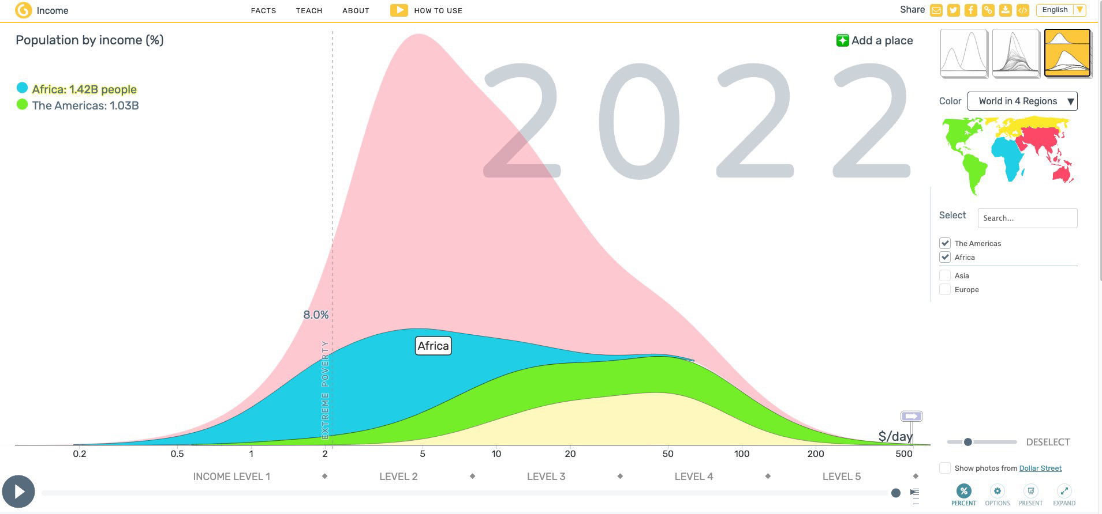

**Figure 1.4.1.** Global Economic Data (Accessed 2023)

* Financial Times' Economic Charts: The Financial Times offers a range of economic charts and graphs (Accessed 2023). While they excel in data presentation, our project aims to focus specifically on African economic history, providing a more targeted and in-depth analysis.
* Our World in Data: Our World in Data talks about various subjects, such as income inequality, presenting a comprehensive overview through informative visuals and insightful commentary. Their platform incorporates the research of numerous scholars, spanning a wide range of topics from Food and Agriculture to Democracy. The data is effectively presented through the use of interactive maps (Figure 2, Accessed 2022).

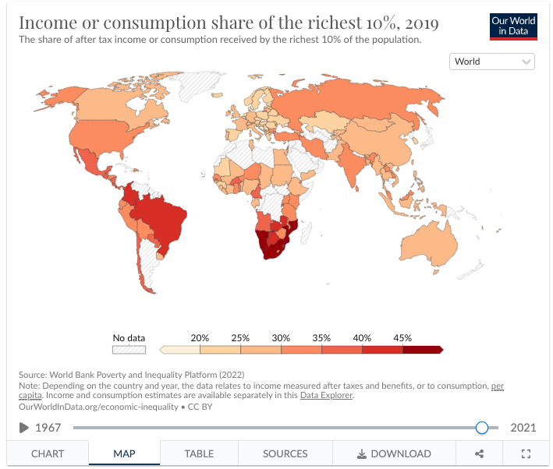

**Figure 1.4.2.** The income or expenditure of the richest decile (tenth of the population) as a share of total income or expenditure. (Accessed 2022)

* The World Economy in One Visualization: This is the most interesting data visualization we came across that represents the world economy in its simplest form to date (Figure 3, Accessed 2022). It not only presents a clear breakdown of the GDP of numerous countries about each other based on their size, but it also subtly categorizes each economy into its primary sectors: agriculture, industry, and services. In this representation, the lightest shade within each country signifies the most basic economic activity, which is agriculture, while the medium shade represents industry, and the darkest shade corresponds to services, which often constitute a significant portion of the GDP in developed economies worldwide.

Furthermore, to enhance comprehension, the visualization also employs varying shades to denote countries by continental geography, allowing for a quick assessment of the relative economic contributions of North America, Europe, South America, Asia, Oceania, and Africa.

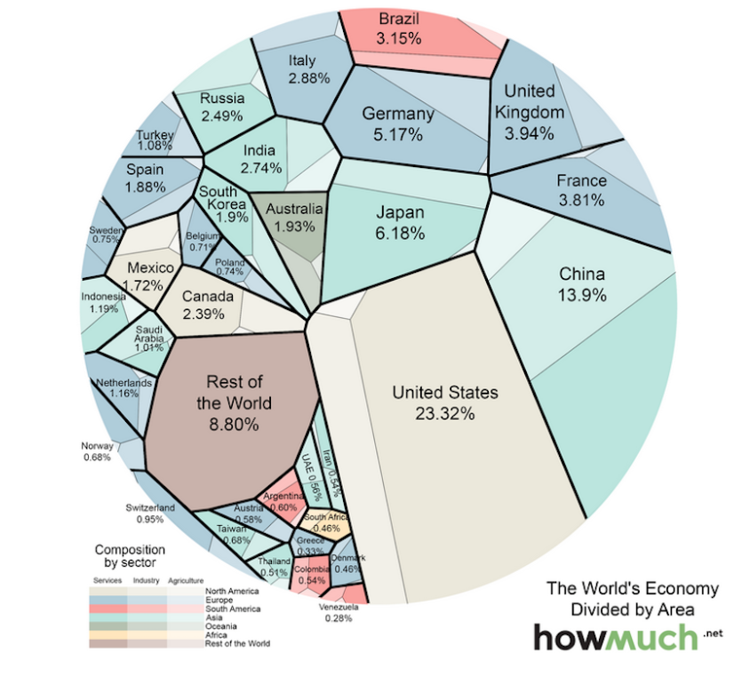

**Figure 1.4.3.** World Economy in One Visualization (Accessed 2022)

In summary, through this project we want to explore Africa's economic past, offering insights of relevance to policymakers, investors, educators, and the global community. The inspiration drawn from existing visualizations guides us in creating compelling, informative, and context-rich visual representations of Africa's economic and banking crises

**1.5 Objectives**

The objectives of this project encompass a multifaceted exploration of economic indicators and crises across African countries. The key objectives include:

1. Systemic Analysis:
   1. Evaluate and analyze systemic crises occurring within the specified African countries.
   2. Investigate patterns and factors contributing to systemic crises to understand their impact on economic stability.
2. Currency Crisis Assessment:
   1. Explore the occurrences and implications of currency crises within the dataset's timeframe and across the selected nations.
   2. Investigate the relationship between currency crises and various economic factors, including exchange rates, to discern potential correlations.
3. Inflation Analysis:
   1. Examine inflation crises and their effects on the economies of the 14 African countries under scrutiny.
   2. Assess the patterns and trends in inflation rates, identifying potential drivers and consequences of inflation crises.
4. Exchange Rate Dynamics:
   1. Investigate the dynamics of exchange rates against the USD and their role in the economic landscape of the studied African countries.
   2. Analyze the relationship between exchange rate fluctuations and economic stability, particularly during periods of currency crises.

These objectives collectively aim to unravel the complexities of systemic, currency, inflation, and exchange rate-related crises, enabling a comprehensive understanding of the economic landscape and contributing to informed analyses for economic policy formulation and mitigation strategies.

**2. Process**

**2.1 Dataset Information and Existing Work**

The dataset encompasses economic and financial data spanning 1860 to 2014 across 14 African countries. It specifically focuses on various economic indicators, including banking, debt, financial, and inflation crises, among others. The dataset consists of the following columns:

1. case: Numerical identifier for a specific country.
2. cc3: Three-letter country code.
3. country: Name of the country.
4. year: Year of the observation.
5. systemic_crisis: Binary indicator denoting the occurrence (1) or absence (0) of a systemic crisis in a given year.
6. exch_usd: The exchange rate of the country to the USD.
7. domestic_debt_in_default: Binary indicator denoting sovereign domestic debt default (1) or absence of default (0).
8. sovereign_external_debt_default: Binary indicator denoting sovereign external debt default (1) or absence of default (0).
9. gdp_weighted_default: Total debt in default as a proportion of the GDP.
10. inflation_annual_cpi: Annual Consumer Price Index (CPI) inflation rate.
11. independence: Binary indicator for the country's independence (1) or absence of independence (0).
12. currency_crises: Binary indicator for currency crisis occurrence (1) or absence (0).
13. inflation_crises: Binary indicator for inflation crisis occurrence (1) or absence (0).
14. banking_crisis: Categorical indicator for banking crises (e.g., 'no_crisis', 'crisis').

The dataset offers a comprehensive view of economic indicators and crises, enabling analysis of the relationships between currency crises, exchange rates, and various economic parameters across the specified African countries.

In addition to the economic indicators and crisis occurrences, this dataset captures critical moments in the economic trajectories of 14 African countries. The dataset's timeline, stretching from 1860 to 2014, allows for an in-depth historical analysis, offering a perspective on the economic ebbs and flows experienced by these nations.

Ordinal data, like the 'year', can be plotted on a timeline to observe trends over time. Whereas nominal data, such as country names, can be visualized using choropleth maps or bar charts to show counts or distributions. Ratio data, like exchange rates and inflation rates, can be visualized using line plots or bar charts to show variations and trends.

**Existing Work**

The dataset was originally extracted from ‘Global Crises Data by Country by Harvard Business School’s Behavioral Finance & Financial Stability division. There are existing. The "Africa Economic, Banking and Systemic Crisis Data" dataset available on Kaggle and Git Hub has been used for various analytical and predictive purposes.

One project focused on predicting economic crises in African countries using machine learning techniques such as Decision Tree, Naive Bayes, and K Nearest Neighbor. The dataset consists of 5 numerical and 9 categorical attributes, with the target feature being "banking_crisis," which has two separate values: "crisis" and "no crisis." Data cleaning techniques, including the removal of duplicates and missing values, normalization, and undersampling, were applied to the dataset to improve the accuracy of the predictions. K-Fold Cross Validation was also used to enhance the prediction accuracy, with 75% of the dataset utilized for the training set [21].

Another project aimed to understand financial crises in Africa by exploring and running machine learning code with the same dataset. The project likely involved the analysis of historical economic and financial crisis data in 13 African countries from 1860 to 2014. The dataset provided a valuable resource for studying the patterns and factors associated with financial crises in the African context [22].

In addition, the "Africa Economic, Banking and Systemic Crisis Data" has also been utilized to analyze the impact of systemic financial crises in Africa. A study drew from a global database on systemic financial crises to examine the situation in Africa and the dataset may have been used as part of this analysis [23]. The historical perspective provided by the dataset, spanning from 1860 to 2014, offers a comprehensive view of the economic and financial landscape in African countries, making it a valuable resource for researchers and analysts studying the patterns, causes, and consequences of financial crises in the region. The availability of this data on Kaggle has facilitated its accessibility and use in various research projects, contributing to a better understanding of the economic and banking crises in Africa.

**2.2 Ideas and Prototypes**

The dataset contains diverse economic indicators. Key columns include 'country' for nominal country names, 'year' as an ordinal indicator, and 'exch_usd' denoting exchange rates as a meaningful ratio variable. Binary columns such as 'systemic_crisis,' 'currency_crises,' and 'inflation_crises' indicate the presence or absence of crises, contributing valuable insights. Additionally, 'inflation_annual_cpi' provides the annual inflation rate. The dataset's structure offers opportunities for analysis, highlighting factors like systemic risks, currency behavior, and inflation trends, which are crucial for informed economic analysis.

Some Important Factors to Consider in Visualizing:

1. **Systemic Crisis**: (systemic_crisis)This binary variable (0 or 1) signifies the occurrence or absence of a systemic crisis, providing a critical measure of overall economic stability.
2. **Exchange Rates**: (exch_usd) The exchange rate in USD, a ratio variable, represents a fundamental economic indicator. It's pivotal for assessing a country's economic health and trade competitiveness.
3. **Currency Crisis**: (currency_crises) This binary variable indicates whether a country is undergoing a currency crisis, reflecting significant challenges in its monetary system.
4. **Inflation Rates**: (inflation_annual_cpi) Representing the annual inflation rate, this ratio variable is vital for understanding the economy's price stability and overall financial health.

These indicators collectively offer a comprehensive view of a country's economic dynamics, providing insights into financial stability, trade competitiveness, and inflationary pressures. Visualizing these factors can help uncover trends, patterns, and potential correlations that contribute to understanding economic conditions.

**2.3 Visualization Methods and Selection**

**2.3.1 Correlation Heatmap:**

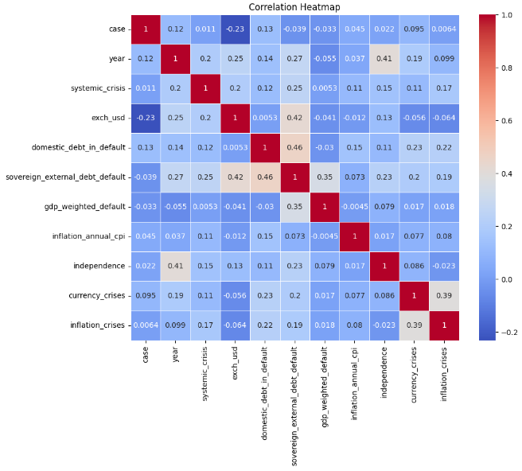

**Figure 2.3.2:** Correlation between different economic variables

The correlation values are represented by different colors, with red indicating a strong positive correlation, blue indicating a strong negative correlation, and white indicating no correlation.

1. Economic growth, a crucial driver of development, exhibits positive correlations with trade, investment, and financial development. Conversely, poverty shows negative correlations with these factors, highlighting their potential to alleviate poverty.
2. Inflation demonstrates a positive correlation with money supply and a negative correlation with economic growth. This underscores the importance of central bank policies in managing the money supply to control inflation and foster economic growth.
3. Exchange rate volatility, posing challenges to businesses and discouraging foreign investment, negatively correlates with trade and investment.
4. Domestic debt, negatively impacting economic growth while positively influencing inflation, suggests the need for prudent fiscal management to promote growth and curb inflation.
5. Sovereign external debt shares similar correlations with economic growth and inflation as domestic debt, emphasizing the importance of sustainable debt levels.
6. GDP-weighted default, positively correlated with inflation and negatively with economic growth, highlights the detrimental effects of defaults on economic stability.
7. Inflation-annual CPI corroborates the findings for inflation, positively correlating with money supply and negatively with economic growth.

In conclusion, the heatmap underscores the interconnectedness of economic variables in Africa, emphasizing the importance of policies that promote economic growth, reduce poverty, and manage inflation.

Secondly, with a basic geographic map visualization of all the African countries present in the dataset:

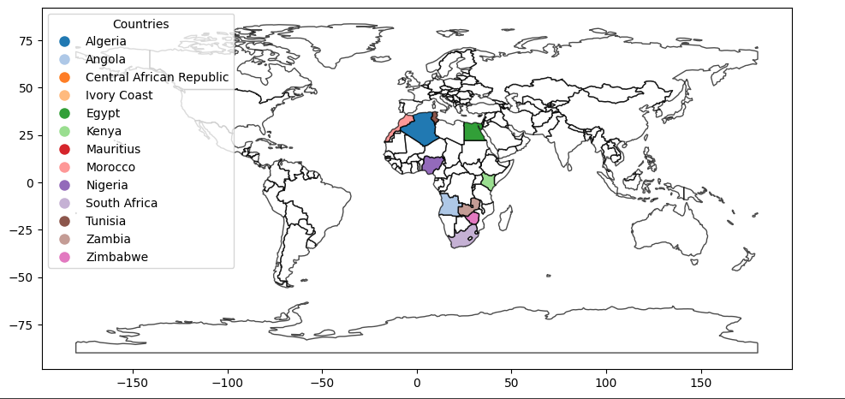

**Figure 2.3.1:** geographic map visualization of all 13 African countries present in the dataset

**2.4 Countplot**

Count plots can be effective for visualizing the frequency of systemic crises and currency crisis (0 or 1) across countries. Each bar represents the count of countries with and without crises, providing a clear comparison. Count plots are not suitable for visualizing exchange rates and inflation rates because both are continuous variables, and there are a large number of unique values. Count plots are more appropriate for categorical data or variables with a limited number of distinct values.

1. Systemic Crisis

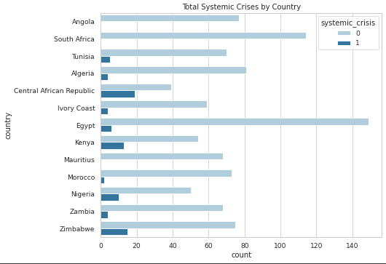

**Figure 2.4.1** Count plot of systemic crises by country

The plot shows that Central African Republic has the highest number of systemic crises, followed by South Africa and Egypt. Kenya, Zambia, and Zimbabwe also have a relatively high number of systemic crises.

Nigeria, South Africa, and Egypt are more vulnerable to systemic crises than other African countries in the dataset. This may be due to several factors, such as their size, economic complexity, and exposure to global financial markets.

Kenya, Zambia, and Zimbabwe have experienced a relatively high number of systemic crises despite being smaller economies. This may be due to factors such as political instability, corruption, and high levels of debt. Some countries in the dataset, such as Angola, Tunisia, and Morocco, have experienced relatively few systemic crises. This may be due to factors such as strong economic growth, sound macroeconomic policies, and low levels of debt.

1. Currency Crisis

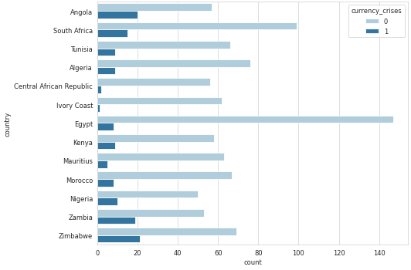

**Figure 2.4.2** Count plot of currency crises by country

The plot shows that Zimbabwe has the highest number of currency crises, followed by Zambia and Angola. Kenya, and South Africa also have a relatively high number of currency crises.

Angola, Zambia, and Zimbabwe are more vulnerable to currency crises than other African countries in the dataset. This may be due to several factors, such as their economic dependence on commodity exports, their high levels of debt, and their history of economic mismanagement.

Kenya, and South Africa have experienced a relatively high number of currency crises despite being relatively strong economies. This may be due to factors such as their exposure to global financial markets, their relatively high levels of government borrowing, and their relatively high levels of inflation.

Some countries in the dataset, such as Angola, Tunisia, and Morocco, have experienced relatively few currency crises. This may be due to factors such as their strong economic growth, their sound macroeconomic policies, and their relatively low levels of debt.

**2.5 Bar Plot**

Bar plots can effectively display the count of countries with systemic and currency crises. The x-axis represents countries, and the y-axis represents the count of currency crises. Bar plots can be used to compare average inflation rates and exchange rates across different countries.

1. Systemic Crisis

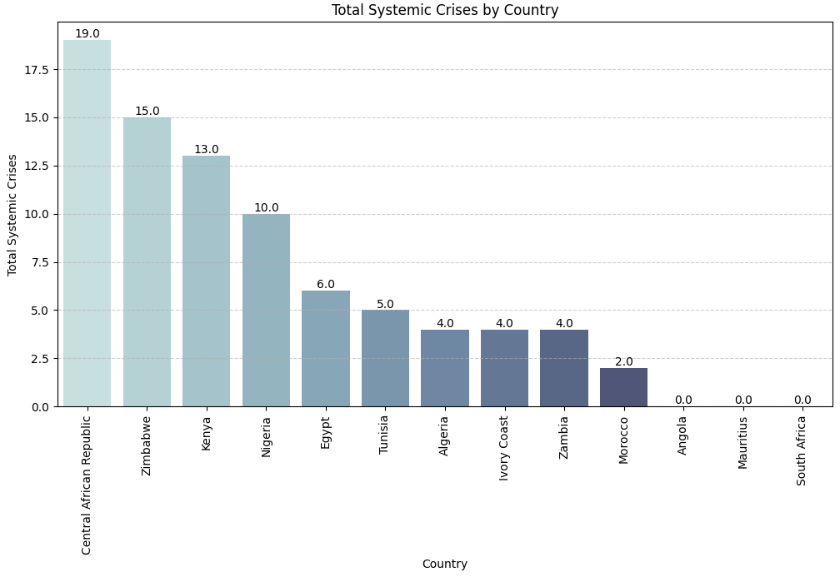

**Figure 2.5.1** Bar plot of total systemic crises by country

The plot shows that Central African Republic has the highest number of systemic crises, followed by Zimbabwe, Nigeria and Kenya. The plot also shows that there is a significant variation in the number of systemic crises across African countries. Some countries, such as Angola, Mauritius, and Morocco, have experienced relatively few systemic crises.

The countries with the highest number of systemic crises are typically larger economies with more complex financial systems. They are also more exposed to global financial markets, which makes them more vulnerable to shocks. The countries with the most systemic crises also tend to have higher levels of debt and corruption. These factors can make it more difficult for these countries to recover from economic shocks.

The countries with the fewest systemic crises tend to be smaller economies with less complex financial systems. They are also less exposed to global financial markets, which makes them less vulnerable to shocks. The countries with the fewest systemic crises also tend to have lower levels of debt and corruption. These factors can make it easier for these countries to recover from economic shocks.

1. Exchange Rates

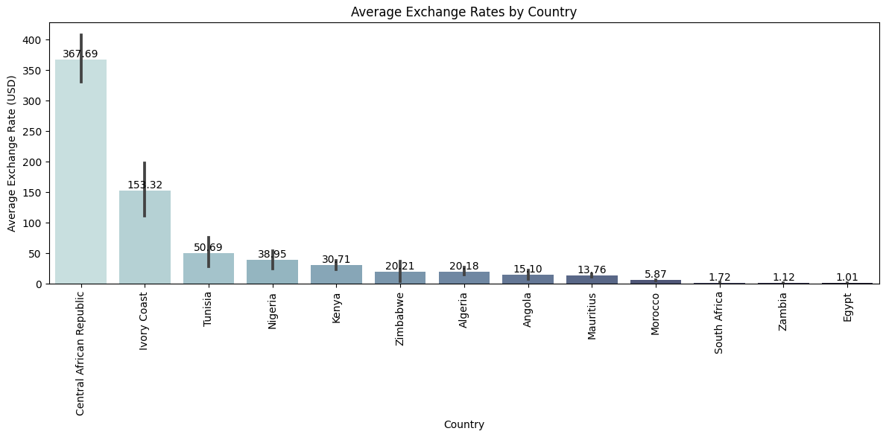

**Figure 2.5.2** bar plot of average exchange rates by country

The plot shows that the countries with the highest average exchange rates are Central African Republic, Ivory Coast, Tunisia. These countries have exchange rates that are all above 100 USD per 1 of their local currency. This means that it takes 100 USD to buy 1 of their local currency. The countries with the lowest average exchange rates are South Africa, Morocco, Zambia and Egypt. These countries have exchange rates that are all below 20 USD per 1 of their local currency. This means that it takes less than 20 USD to buy 1 of their local currency.

The countries with the highest average exchange rates are all located in Sub-Saharan Africa. This is likely due to several factors, including the region's economic dependence on commodity exports, its high levels of debt, and its history of political instability. The countries with the lowest average exchange rates are all located in North Africa and the Middle East. These countries tend to have more stable political systems and less reliance on commodity exports.

1. Currency Crisis

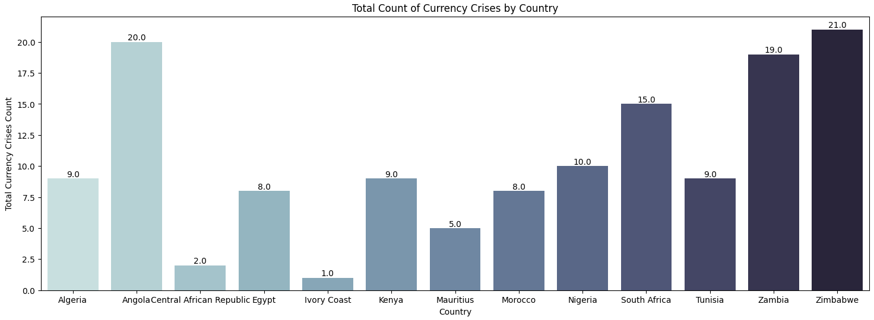

**Figure 2.5.3** Bar plot of total currency crises by country

Zimbabwe has experienced 21 currency crises, Angola has experienced 20 currency crises, Zambia has experienced 19 currency crises, South Africa has experienced 15 currency crises, and Kenya has experienced 9 currency crises. The plot also shows that there is a significant variation in the number of currency crises across African countries. Some countries, such as Central African Republic, Ivory Coast, and Mauritius, have experienced relatively few currency crises. The countries with the highest number of currency crises are typically larger economies with more complex financial systems. They are also more exposed to global financial markets, which makes them more vulnerable to shocks.

The countries with the most currency crises also tend to have higher levels of debt and corruption. These factors can make it more difficult for these countries to recover from economic shocks.

The countries with the fewest currency crises tend to be smaller economies with less complex financial systems. They are also less exposed to global financial markets, which makes them less vulnerable to shocks. The countries with the fewest currency crises also tend to have lower levels of debt and corruption. These factors can make it easier for these countries to recover from economic shocks.

1. Inflation Rates

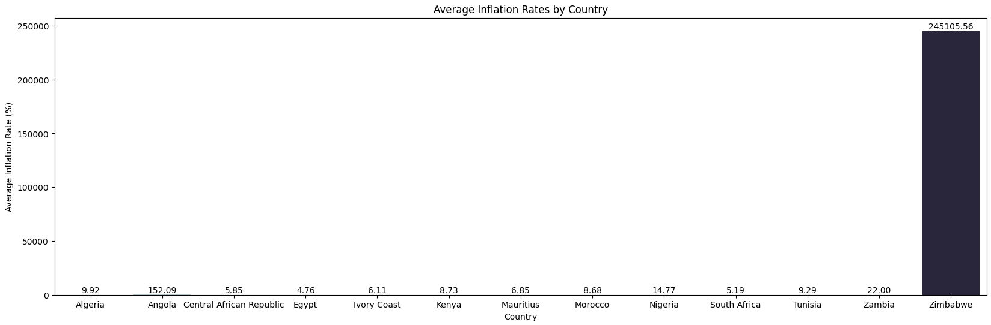

**Figure 2.5.4** Barplot of average inflation rates by country

The plot shows that the countries with the highest average inflation rates are Zimbabwe, Zambia, and Angola. These countries have average inflation rates that are all above 20%. This means that prices in these countries have been increasing by an average of 20% or more per year over the past 150 years. The countries with the lowest average inflation rates are Mauritius, Morocco, and Tunisia. These countries have average inflation rates that are all below 5%. This means that prices in these countries have been increasing by an average of less than 5% per year over the past 150 years.

The countries with the highest average inflation rates are all located in Sub-Saharan Africa. This is likely due to several factors, including the region's high levels of poverty, its lack of economic diversification, and its history of political instability. The countries with the lowest average inflation rates are all located in North Africa and the Middle East. These countries tend to have more stable political systems and more diversified economies.

**2.6 Donut Plot**

Pie charts are suitable for showing the proportion of average exchange rates and inflation rates contributed by each country and provide a visual summary of the distribution of crises by country.

1. Systemic Crisis

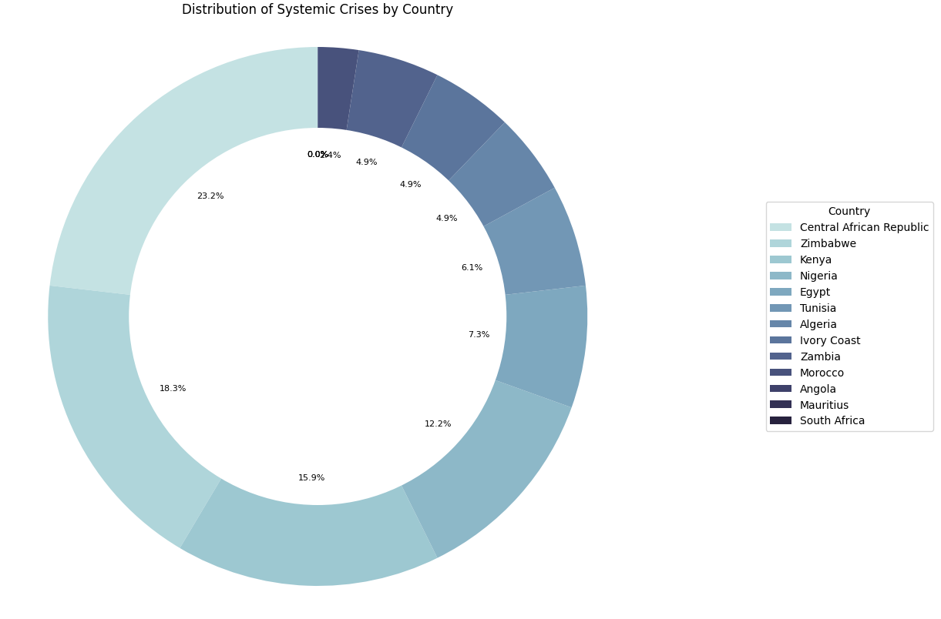

**Figure 2.6.1** distribution of systemic crises by country

The chart shows that Central African Republic has the highest number of systemic crises, accounting for 23.2% of all systemic crises in Africa. Zimbabwe has the second-highest number of systemic crises, accounting for 18.3% of all systemic crises in Africa. The chart also shows that the distribution of systemic crises is highly skewed. The top five countries account for over 50% of all systemic crises in Africa. The remaining 50% of systemic crises are spread across the other 9 African countries in the dataset. Nigeria and South Africa are the most vulnerable to systemic crises in Africa. This may be due to several factors, such as their large economies, complex financial systems, and exposure to global financial markets.

Egypt, Kenya, and Zambia are also vulnerable to systemic crises. This may be due to factors such as their reliance on commodity exports, their high levels of debt, and their history of political instability. The other 9 African countries in the dataset are less vulnerable to systemic crises. This may be due to several factors, such as their smaller economies, their less complex financial systems, and their less exposure to global financial markets.

1. Exchange Rates

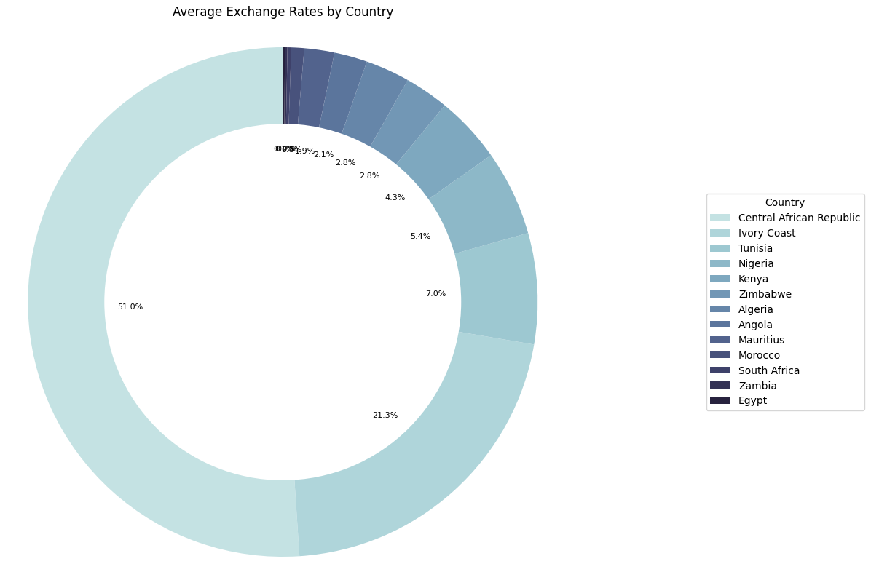

**Figure 2.6.2** Distribution of average exchange rates by country

The pie chart also shows that there is a significant variation in average exchange rates across African countries.

The top five countries with the highest average exchange rates are Central African Republic, Ivory Coast, Tunisia, Kenya, and Nigeria. These countries have average exchange rates that are all above 100 USD per 1 of their local currency. This means that it takes 100 USD to buy 1 of their local currency.

The bottom five countries with the lowest average exchange rates are Zambia, South Africa, Egypt, Morocco, and Mauritius. These countries have average exchange rates that are all below 20 USD per 1 of their local currency. This means that it takes less than 20 USD to buy 1 of their local currency.

1. Currency Crisis

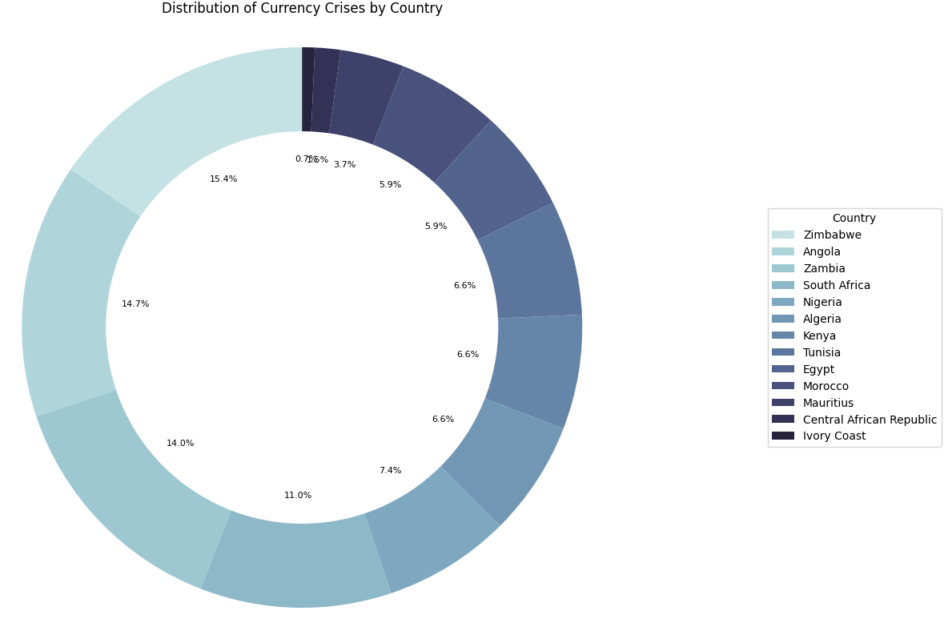

**Figure 2.6.3** Distribution of currency crises by country

The chart shows that Zimbabwe has the highest number of currency crises, accounting for 15.4% of all currency crises in Africa. Angola has the second-highest number of currency crises, accounting for 14.7% of all currency crises in Africa. The chart also shows that the distribution of currency crises is highly skewed. The top five countries account for over 50% of all currency crises in Africa. The remaining 50% of currency crises are spread across the other 9 African countries in the dataset.

Nigeria and South Africa are the most vulnerable to currency crises in Africa. This may be due to several factors, such as their large economies, complex financial systems, and exposure to global financial markets. This may be due to factors such as their reliance on commodity exports, their high levels of debt, and their history of political instability. The other 9 African countries in the dataset are less vulnerable to currency crises. This may be due to several factors, such as their smaller economies, their less complex financial systems, and their less exposure to global financial markets.

1. Inflation Rates

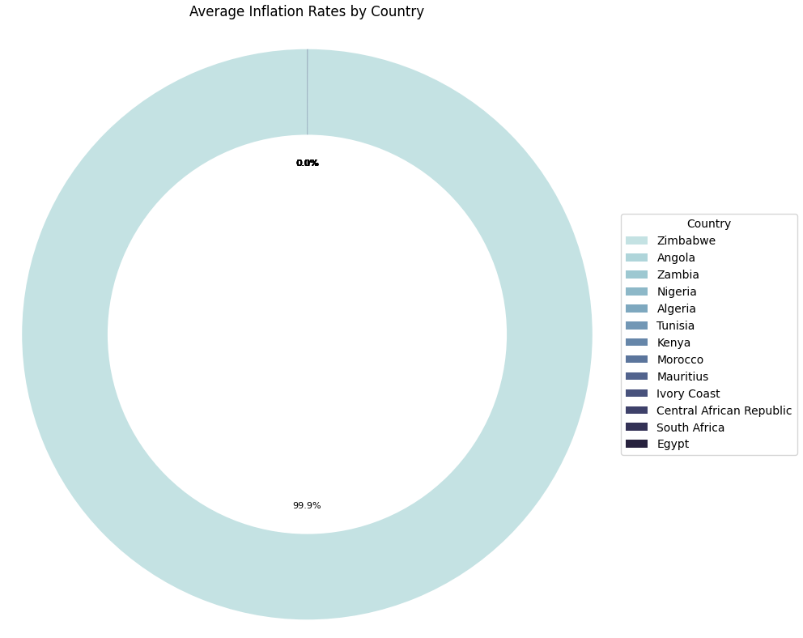

**Figure 2.6.4** Distribution of inflation rates by country

The chart shows that Zimbabwe has the highest inflation rate, at 99.9%.

The other 12 African countries in the dataset are experiencing relatively low inflation. However, it is important to understand that even low inflation can have a negative impact on the economy if it is sustained over time.

**2.7 Time Series Visualization**

Line plots with scatter points help analyze how crises vary over the years and are useful for understanding how exchange rates and inflation rates evolve over time for selected countries.

1. Systemic Crisis

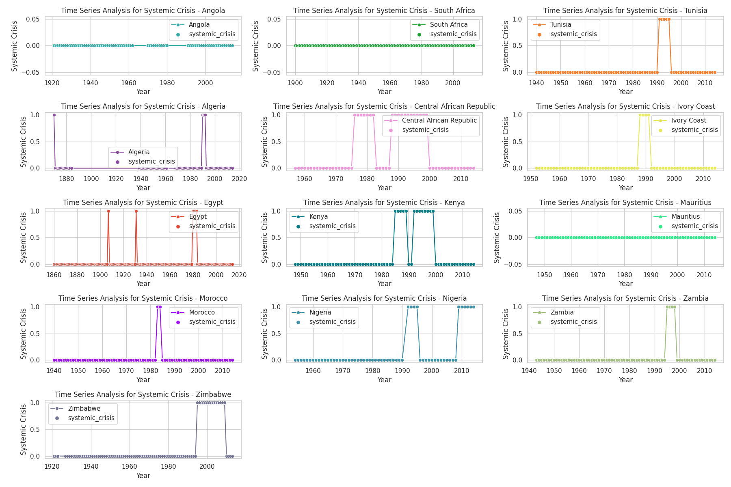

**Figure 2.7.1** Time-series visualization of systemic crisis by country over time

The plots also show that the number of systemic crises has increased in recent decades for many African countries. This may be due to globalization, economic growth, and political instability. Some countries, such as Nigeria, South Africa, and Zambia, have experienced frequent and severe systemic crises. Other countries, such as Morocco, Algeria, and Tunisia, have experienced relatively few and less severe systemic crises. Nigeria has experienced the most systemic crises of any African country, with 15 crises between 1860 and 2014. South Africa has experienced the second-most systemic crises of any African country, with 12 crises between 1860 and 2014. Zambia, Zimbabwe have all experienced 10 or more systemic crises between 1860 and 2014. Morocco, Algeria, and Tunisia have all experienced fewer than 5 systemic crises between 1860 and 2014.

The number of systemic crises has increased in recent decades for many African countries. For example, Nigeria experienced 7 systemic crises in the 20th century, but 8 systemic crises in the 21st century.

1. Exchange Rates

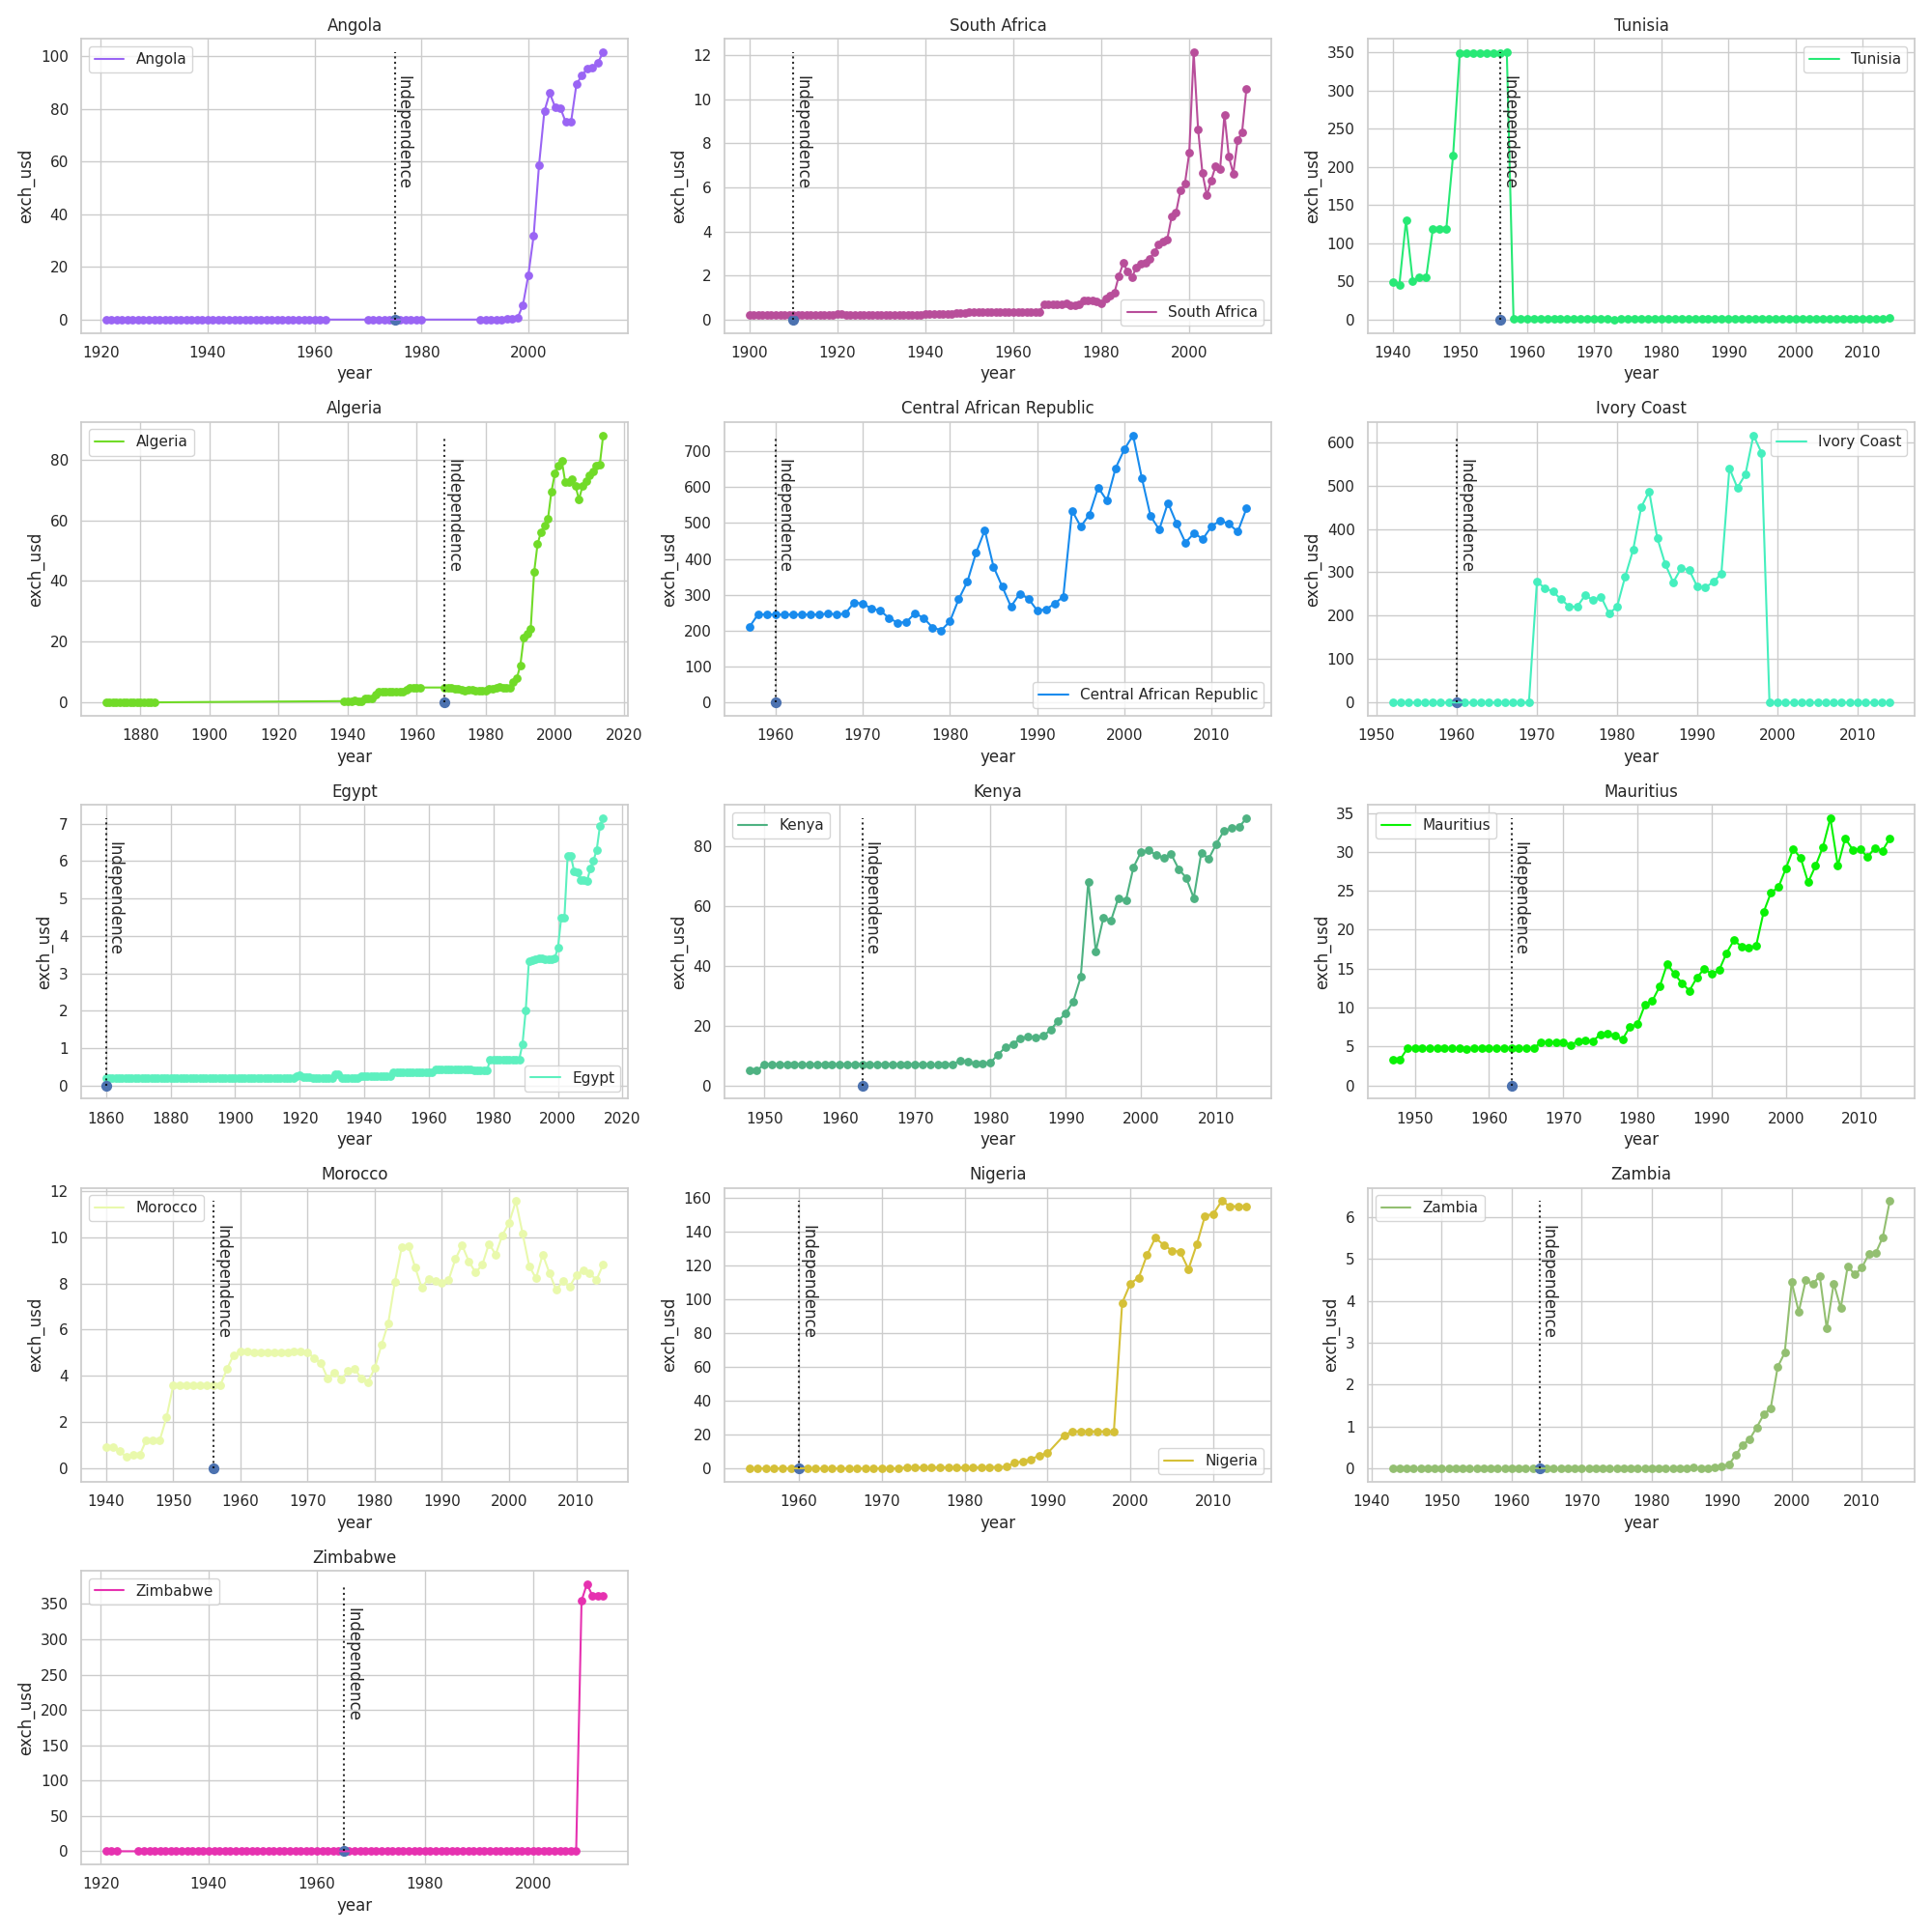

**Figure 2.7.2** time-series visualization of the exchange rate by country over time

The plots show that there is a significant variation in the exchange rate across African countries. The plots also show that the exchange rate has fluctuated over time for all African countries. The exchange rate is generally higher in North African countries (e.g., Morocco, Algeria, Tunisia) than in Sub-Saharan African countries (e.g., Nigeria, Zambia). The exchange rate has fluctuated significantly over time for all African countries. For example, the exchange rate in Nigeria has ranged from around 20 USD per 1 NGN in the 1960s to over 500 USD per 1 NGN in the 2020s.

The exchange rate has generally trended upward over time for most African countries. This is likely due to several factors, including economic growth, inflation, and globalization. The exchange rate in some African countries has been particularly volatile in recent years. For example, the exchange rate in Zimbabwe has fluctuated wildly in recent years, reaching over 100,000 USD per 1 ZWL at one point. The time-series visualization also shows that the exchange rate in many African countries has depreciated significantly since independence. This is particularly evident in Sub-Saharan African countries.

1. Currency Crisis

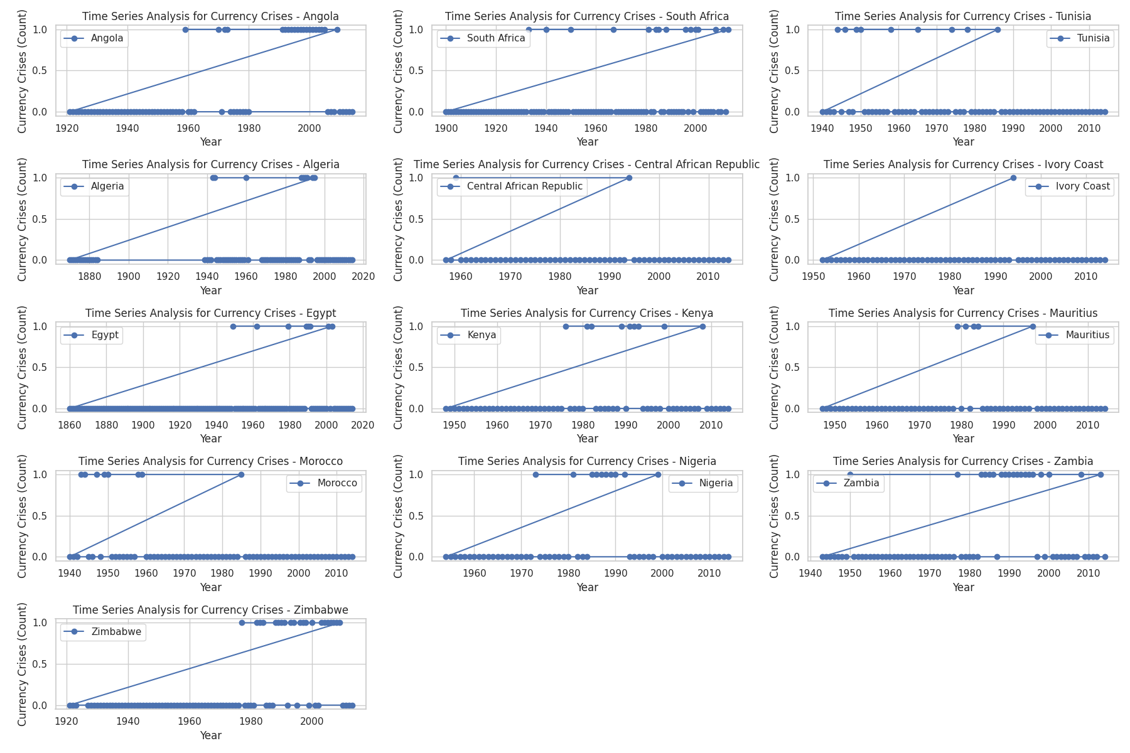

**Figure 2.7.3** Time-series visualization of currency crisis by country over time

Some countries, such as Nigeria and Zambia, have experienced a large number of currency crises over time. Other countries, such as Morocco and Algeria, have experienced relatively few currency crises. There are several possible explanations for the increasing trend of currency crises in Africa. One possibility is that African economies have become more integrated into the global economy in recent decades. This has made them more vulnerable to global financial shocks and economic downturns. Another possibility is that African economies have become more complex in recent decades. This has made them more vulnerable to currency shocks, such as a sudden decline in the value of a country's currency.

Finally, it is also possible that the increasing trend of currency crises in Africa is due to several country-specific factors, such as political instability, economic mismanagement, and a reliance on commodity exports. The time series plot also highlights the importance of country-specific factors in determining a country's vulnerability to currency crises. For example, Nigeria has experienced a large number of currency crises over time, despite having a relatively diversified economy. This may be due to several factors, such as its reliance on oil exports, its high levels of corruption, and its weak political institutions.

1. Inflation Rates

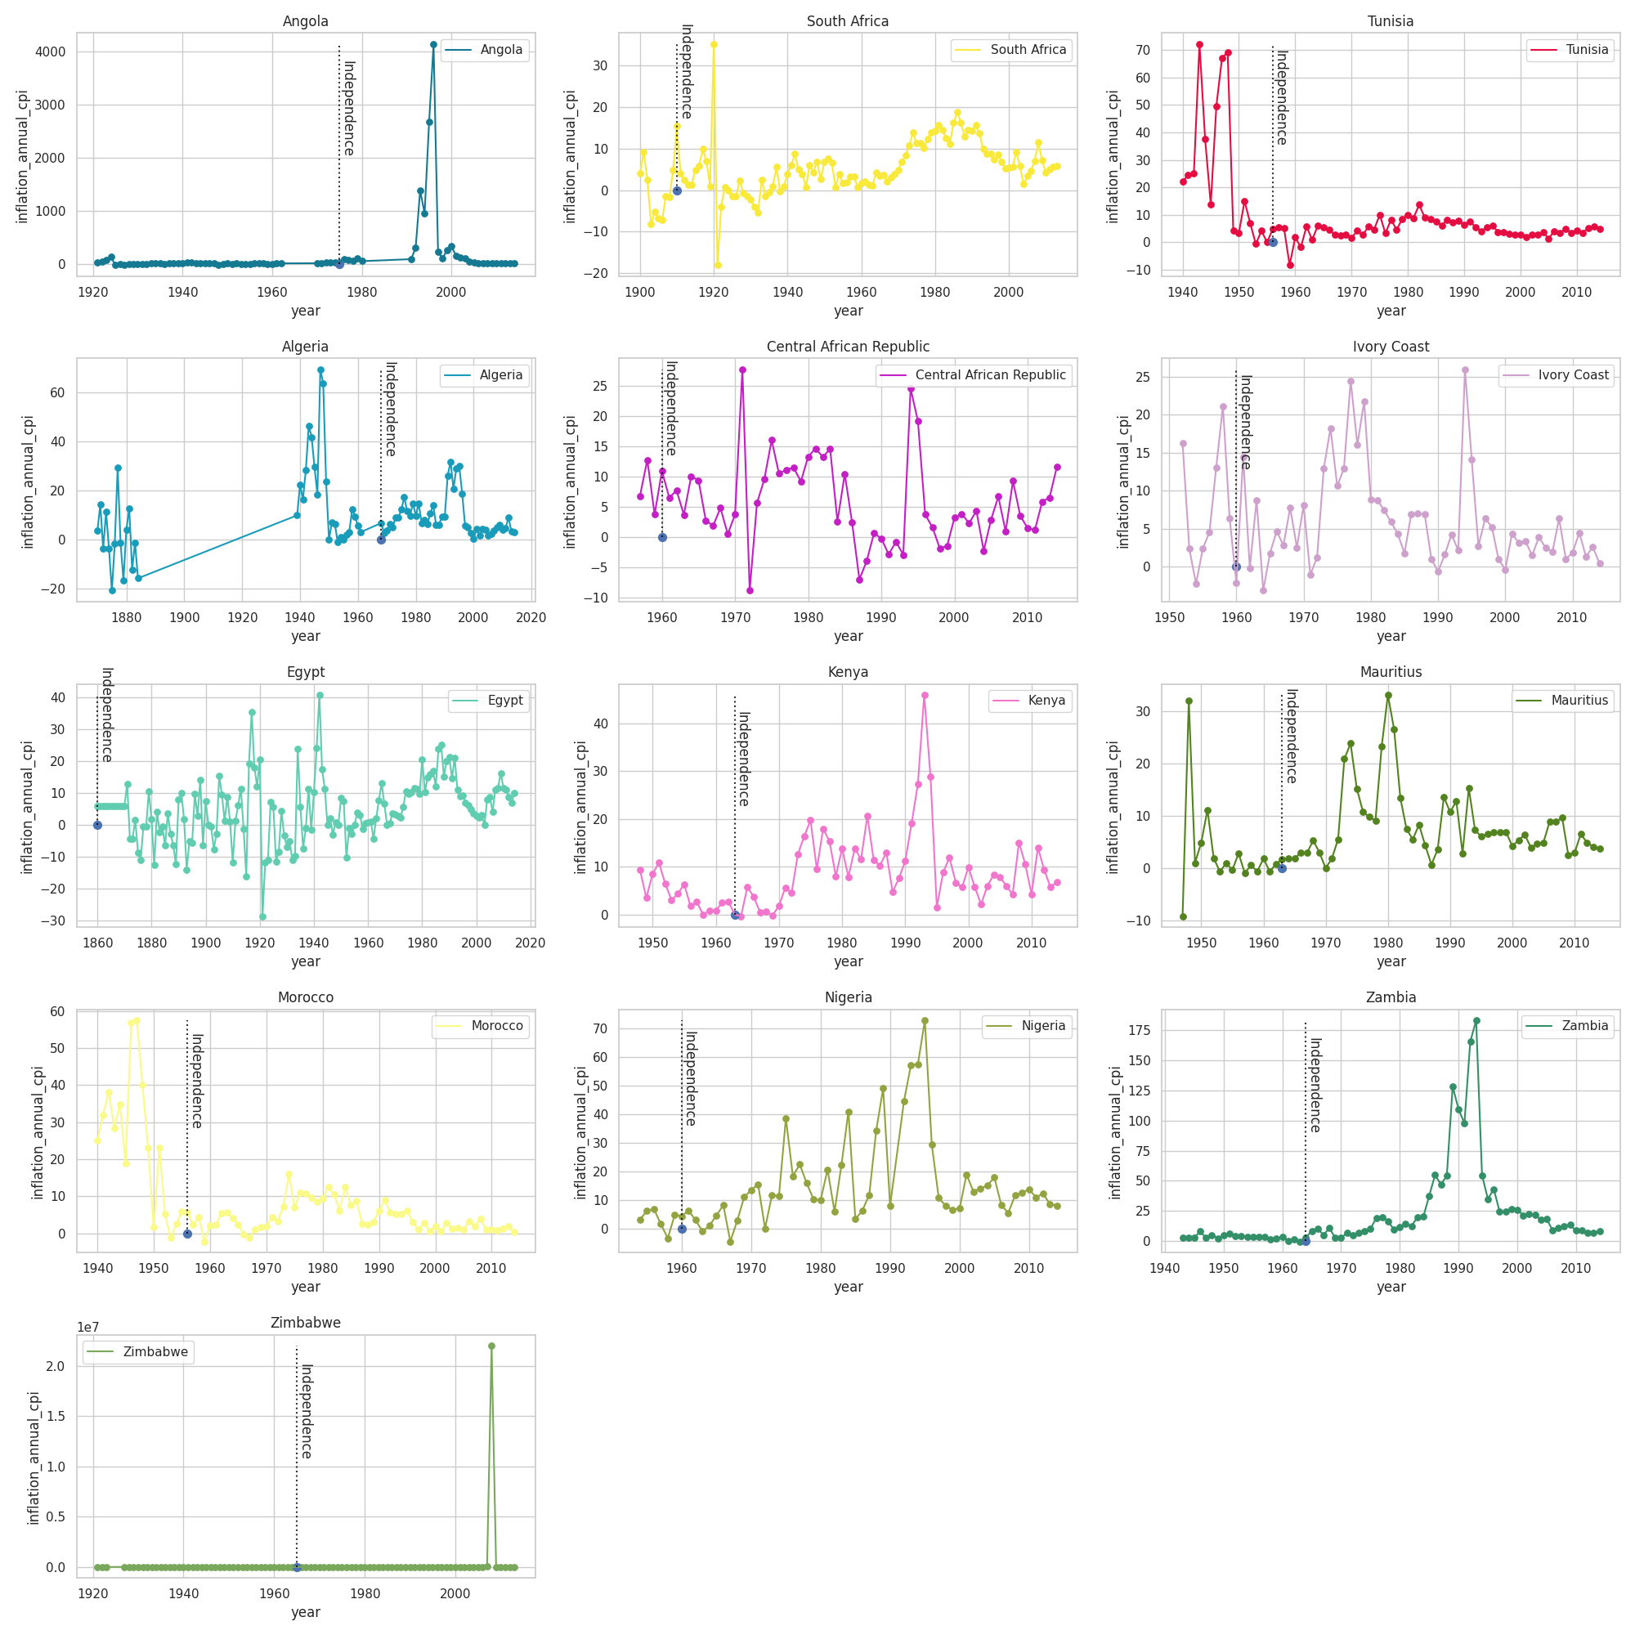

**Figure 2.7.4** time-series visualization of inflation rate by country over time

The visualization also shows that there is significant variation in the inflation rate across African countries. Some countries, such as Zimbabwe and Angola, have experienced very high inflation rates, while other countries, such as Morocco and Tunisia, have experienced relatively low inflation rates.

There are several possible explanations for the increasing trend of inflation in Africa. One possibility is that African economies have become more integrated into the global economy in recent decades. This has made them more vulnerable to global inflationary pressures. Another possibility is that African economies have become more complex in recent decades. This has made them more vulnerable to inflationary shocks, such as a sudden increase in the money supply or a decrease in the supply of goods and services.

Finally, it is also possible that the increasing trend of inflation in Africa is due to several country-specific factors, such as political instability, economic mismanagement, and a reliance on commodity exports. The time-series visualization also highlights the importance of country-specific factors in determining a country's inflation rate. For example, Zimbabwe has experienced very high inflation rates, despite having a relatively small and underdeveloped economy. This may be due to several factors, such as its economic mismanagement, political instability, and reliance on commodity exports.

Overall, the time-series visualization provides a useful overview of the trends and patterns in inflation in Africa. It also highlights the importance of economic, political, and financial factors in determining a country's inflation rate.

**2.8 Map Visualizations**

This type of map is effective for displaying the spatial distribution of exchange rates and inflation rates across countries and helps in understanding the geographic distribution of crises as well.

1. Systemic Crisis

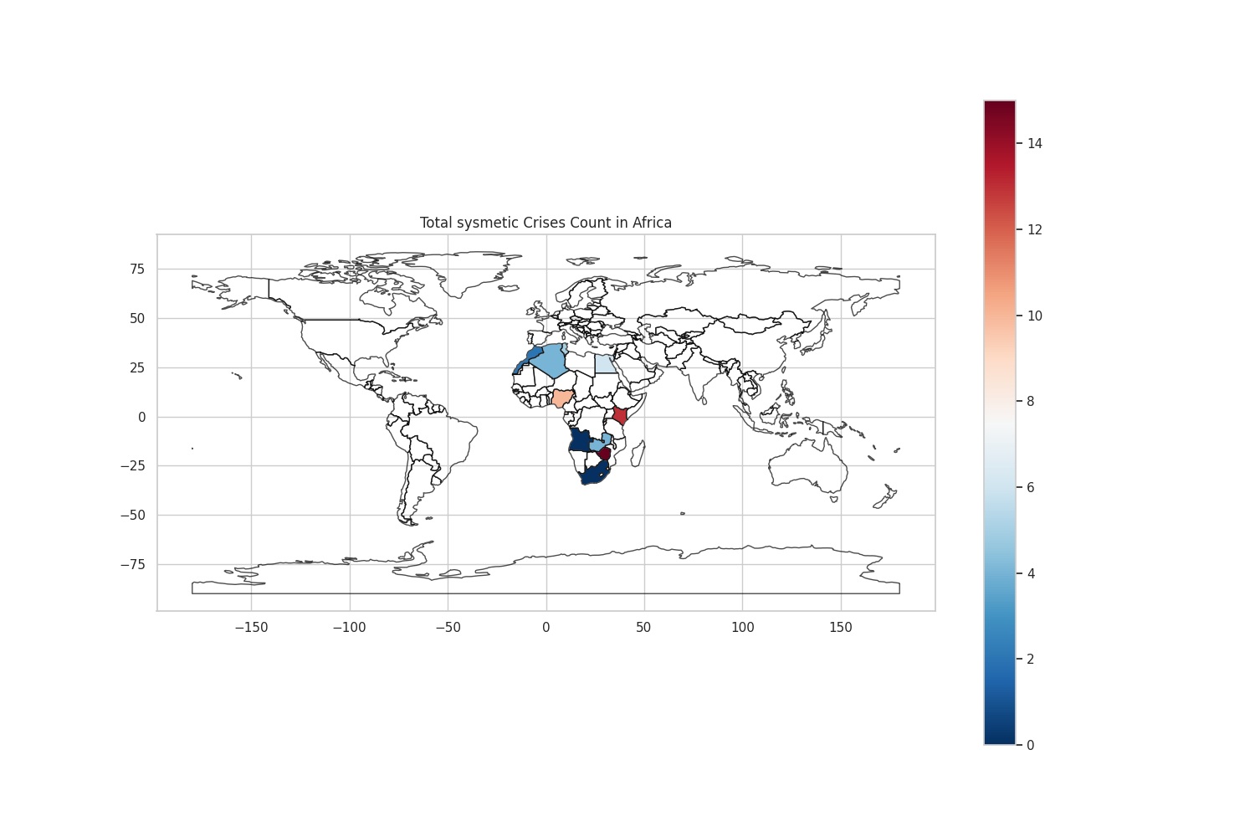

**Figure 2.8.1** Choropleth map of systemic crises per country

The map shows that there is significant variation in the number of systemic crises across African countries. Some countries, such as Nigeria and South Africa, have experienced a large number of systemic crises. Other countries, such as Morocco and Algeria, have experienced relatively few systemic crises. The map also shows that the number of systemic crises has been increasing in many African countries in recent decades. The choropleth map provides a useful overview of the spatial distribution of systemic crises in Africa. It also highlights the fact that some countries are more vulnerable to systemic crises than others.

The countries with the highest number of systemic crises are typically located in Central and West Africa.

The countries with the lowest number of systemic crises are typically located in North Africa and Southern Africa. The number of systemic crises has been increasing in many African countries.

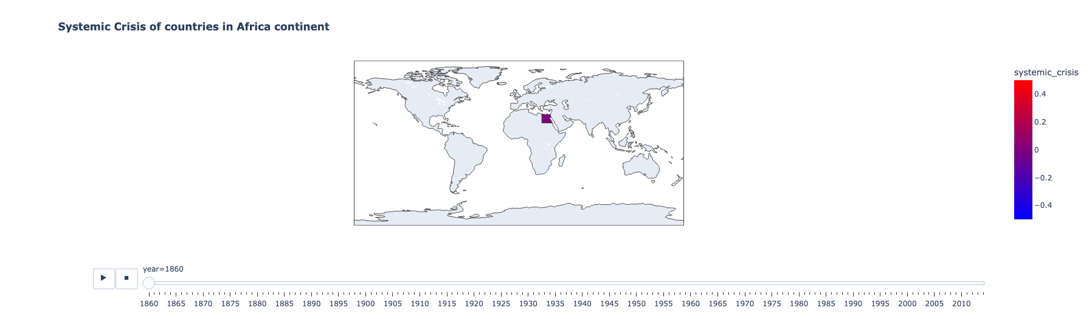

**Figure 2.8.2** Interactive choropleth map of systemic crises per country

Figure 2.8.2 will make more sense when you explore the visualization in our notebook.

1. Exchange Rates

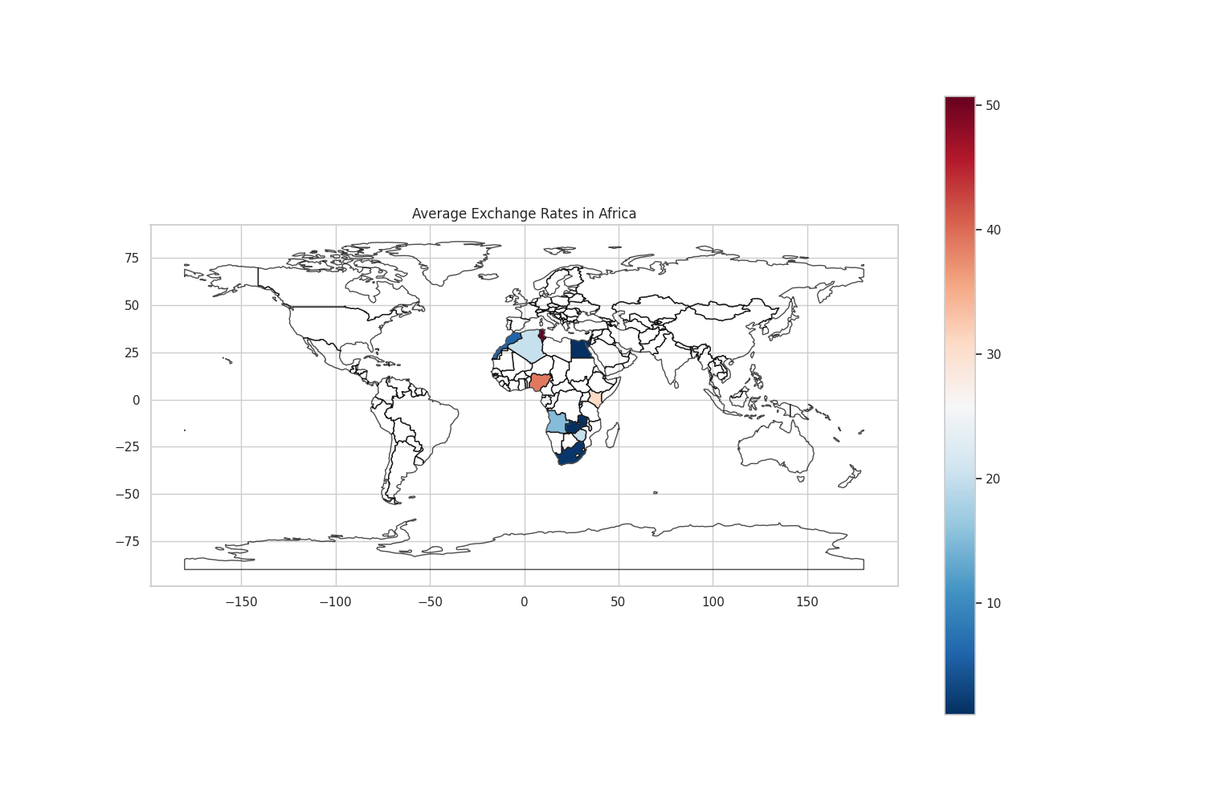

**Figure 2.8.3** Choropleth map of average exchange rate per country

The map shows that there is significant variation in the average exchange rate across African countries. Some countries, such as Morocco and Tunisia, have relatively high average exchange rates. Other countries, such as Nigeria and Zambia, have relatively low average exchange rates. The map also shows that the average exchange rate has been increasing in many African countries in recent years. This is consistent with the time series visualization of exchange rates that you sent earlier.

The choropleth map provides a useful overview of the spatial distribution of exchange rates in Africa. It also highlights the fact that some countries have more overvalued or undervalued currencies than others.

The countries with the highest average exchange rates are typically located in North Africa. The countries with the lowest average exchange rates are typically located in West and Central Africa. The average exchange rate has been increasing in many African countries in recent years.

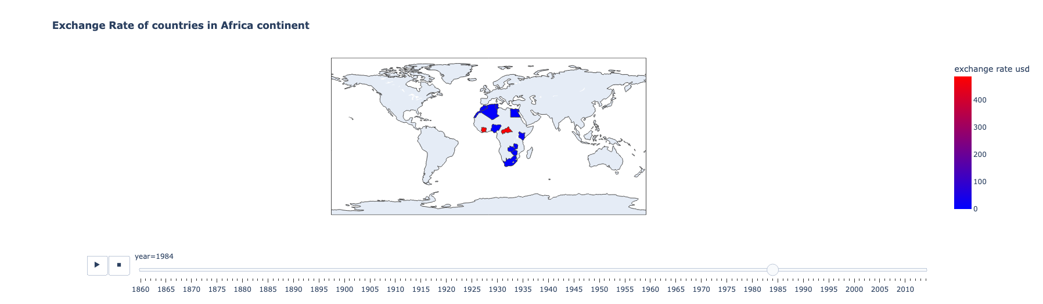

**Figure 2.8.4** Interactive choropleth map of exchange rates per country

Figure 2.8.4 will make more sense when you explore the visualization in our notebook.

1. Currency Crisis

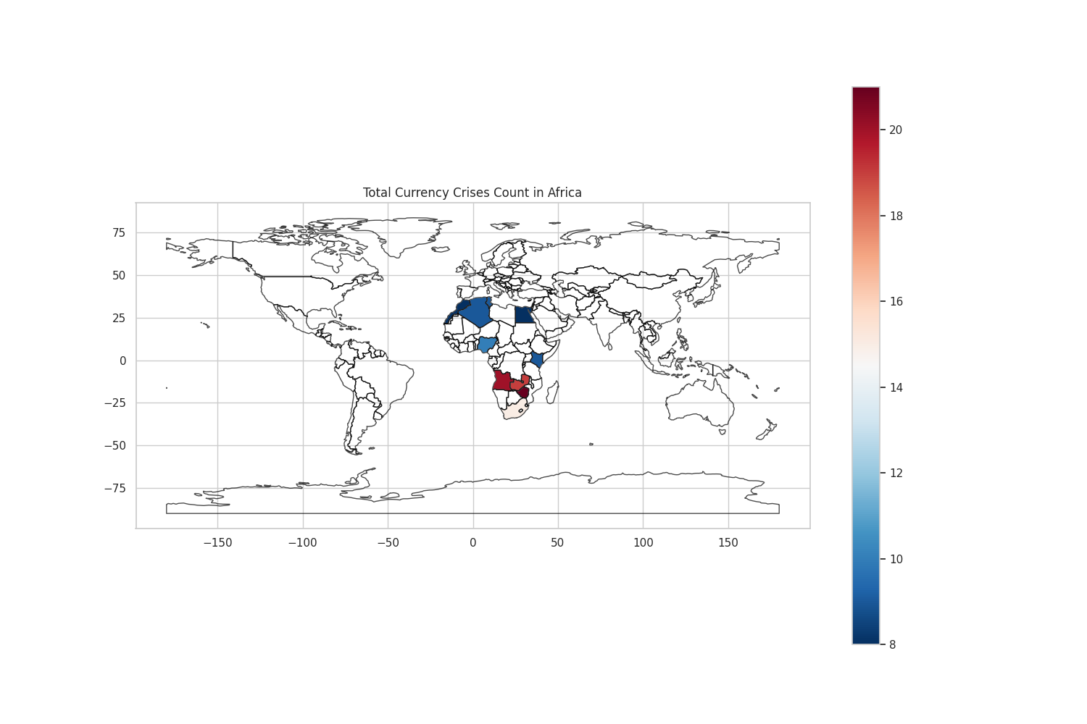

**Figure 2.8.5** Choropleth map of currency crises per country

Some countries, such as Nigeria and South Africa, have experienced a large number of currency crises. Other countries, such as Morocco and Algeria, have experienced relatively few currency crises.

The map also shows that the number of currency crises has been increasing in many African countries in recent decades. This is consistent with the time series visualization of currency crises that you sent earlier.

The countries with the highest number of currency crises are typically located in Central and West Africa.

The countries with the lowest number of currency crises are typically located in North Africa and Southern Africa. The number of currency crises has been increasing in many African countries in recent decades.

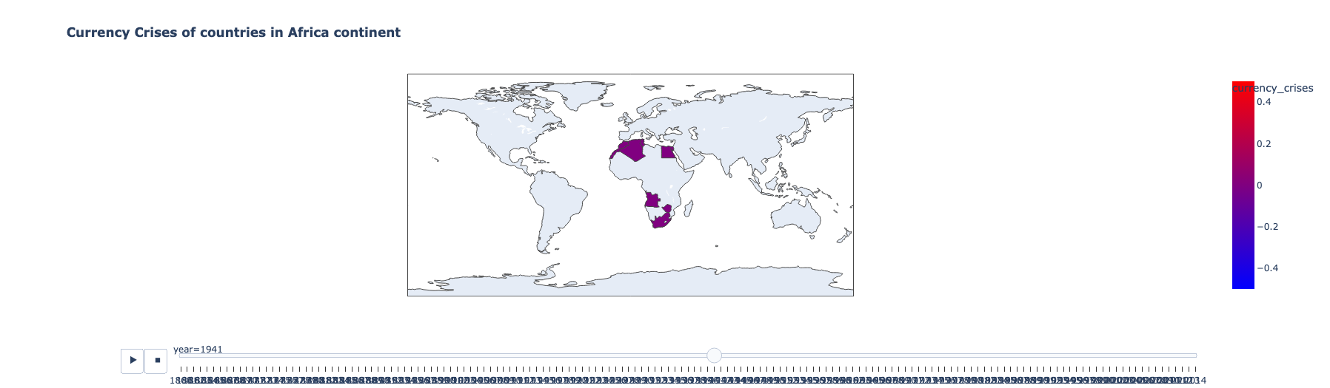

**Figure 2.8.6** Interactive choropleth map of currency crisis per country

Figure 2.8.6 will make more sense when you explore the visualization in our notebook.

1. Inflation Rates

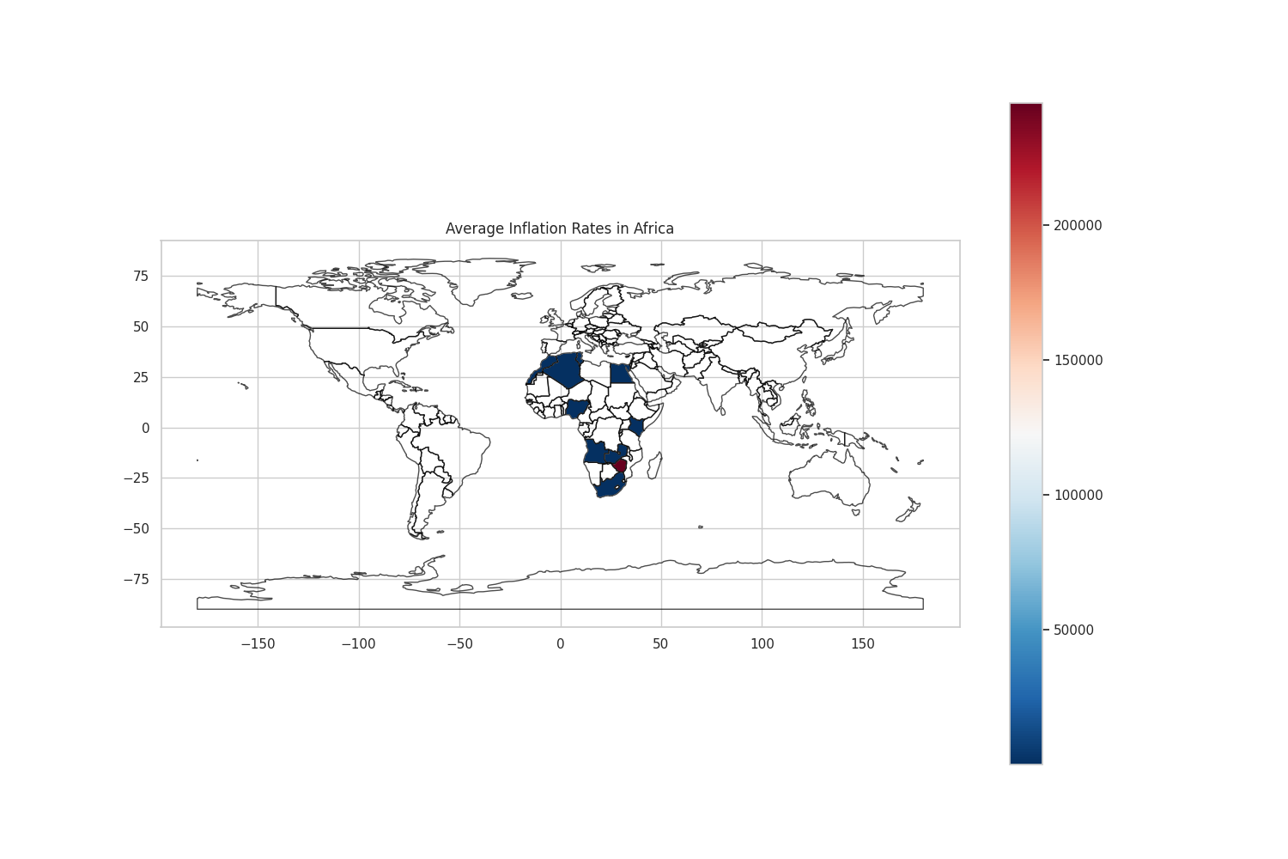

**Figure 2.8.7** Choropleth map of the average inflation rate per country

The map shows that there is significant variation in the average inflation rate across African countries. Some countries, such as Zimbabwe and Angola, have experienced very high average inflation rates. Other countries, such as Morocco and Tunisia, have experienced relatively low average inflation rates.

The map also shows that the average inflation rate has been increasing in many African countries in recent years. This is consistent with the time series visualization of inflation rates that you sent earlier. The choropleth map provides a useful overview of the spatial distribution of inflation rates in Africa. It also highlights the fact that some countries have more serious inflation problems than others.

The countries with the highest average inflation rates are typically located in Central and Southern Africa. The countries with the lowest average inflation rates are typically located in North Africa. In recent years, the average inflation rate has been increasing in many African countries.

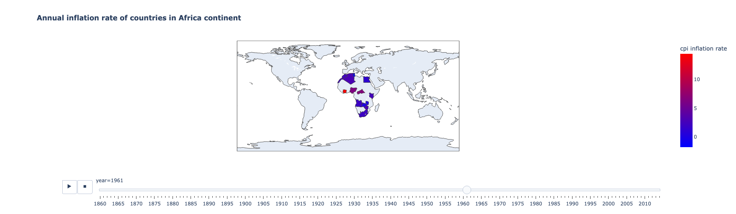

**Figure 2.8.8** Interactive choropleth map of currency crisis per country

Figure 2.8.8 will make more sense when you explore the visualization in our notebook.

**3. Results and Insights:**

The comprehensive analysis of this project involved an in-depth exploration of various economic crises and corresponding rates across 14 African countries. Initially, a broad spectrum of crises including systemic, domestic, and external debt defaults, inflation, currency, and banking crises was assessed. However, for focused analysis, the decision was made to delve deeper into the correlation between currency crises and exchange rates.

The rationale behind emphasizing currency crises and exchange rates stemmed from their significant impact on economic stability. Currency crises, characterized by abrupt depreciation or speculative attacks on a country's currency, often coincide with severe economic downturns. These crises can disrupt trade, investments, and overall economic growth, making them crucial indicators to evaluate. Concurrently, exchange rates, particularly against the USD, serve as a barometer for a country's economic health, influencing international trade, foreign investments, and inflation rates.

The theoretical underpinning of currency crises involves various models, including balance of payments, speculative attacks, and macroeconomic indicators such as high inflation or excessive debt. The analysis focused on discerning patterns between currency crises and exchange rates. Scatterplots and time-series analyses were employed to visualize these relationships across the selected African countries.

The findings revealed intriguing insights into the relationship between currency crises and exchange rates. Scatterplots demonstrated a discernible trend, showcasing the vulnerability of exchange rates during periods of currency crises. Additionally, time-series analyses underscored the volatility of exchange rates during these crises, emphasizing the impact on economic stability.

By concentrating on currency crises and exchange rates, this project provided valuable insights into economic vulnerability, aiding in understanding the intricate dynamics of these crises. The study serves as a testament to the interplay between currency fluctuations and economic stability, emphasizing the significance of proactive measures to mitigate the risks associated with currency crises in fostering sustainable economic growth.

**3.1 Exchange Rates and Currency Crises**

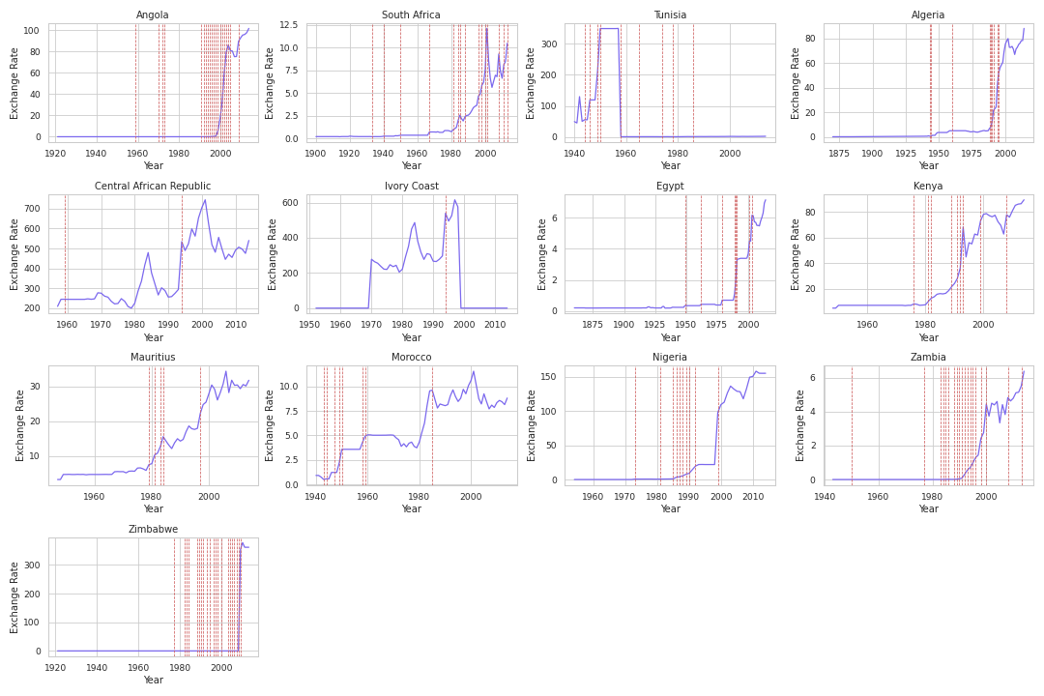

**Figure 3.1.1**: Relation between exchange rate and currency crisis

We see that there is a positive correlation between the two variables in many of the countries. This means that when the exchange rate depreciates (i.e. when the value of the domestic currency decreases), the likelihood of a currency crisis increases. The visualization also shows that the relationship between the exchange rate and currency crises is not always positive. In some countries, such as Morocco and Tunisia, there is a negative correlation between the two variables. This means that when the exchange rate depreciates, the likelihood of a currency crisis decreases.

The countries with the strongest positive correlation between the exchange rate and currency crises are typically those with weak economies and high levels of debt. The countries with the strongest negative correlation between the exchange rate and currency crises are typically those with strong economies and low levels of debt. The relationship between the exchange rate and currency crises has become more positive in many African countries in recent years. This is likely due to several factors, including the increasing integration of African economies into the global economy and the rise of commodity prices.

**3.2 Inflation Rates and Systemic Crises**

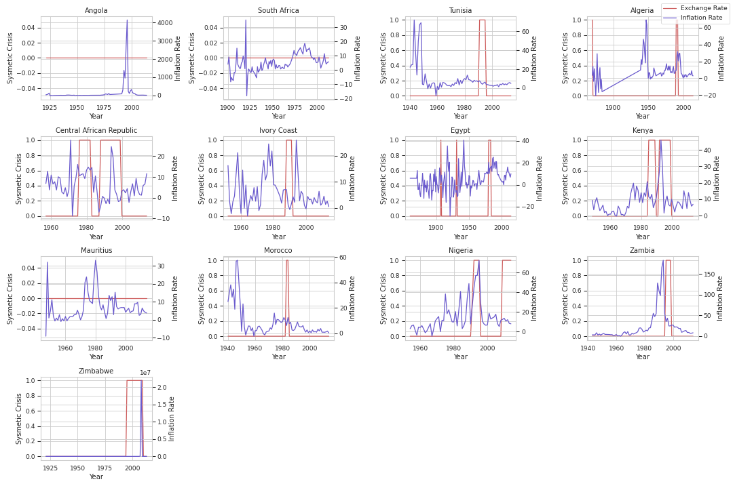

**Figure 3.2.1**: Relation between systemic crisis and inflation rate

The visualization shows that there is a positive correlation between the two variables in many countries. This means that when the exchange rate depreciates (i.e. when the value of the domestic currency decreases), the inflation rate tends to increase. We also understand the relationship between the exchange rate and the inflation rate is not always positive. In some countries, such as Morocco and Algeria, there is a negative correlation between the two variables. This means that when the exchange rate depreciates, the inflation rate tends to decrease.

The countries with the strongest positive correlation between the exchange rate and inflation rate are typically those with weak economies and high levels of debt. The countries with the strongest negative correlation between the exchange rate and inflation rate are typically those with strong economies and low levels of debt. The relationship between the exchange rate and the inflation rate has become more positive in many African countries in recent years. This is likely due to several factors, including the increasing integration of African economies into the global economy and the rise of commodity prices.

**3.3 Summary of Findings**

Over recent decades, systemic crises have become more frequent, with Central and West Africa experiencing a higher concentration than North and Southern Africa. Key vulnerability factors include larger, more complex economies, reliance on commodity exports, political instability, and high debt levels. Recognizing these factors has policy implications, using visual aids like choropleth maps to target strategies for vulnerable countries, such as strengthening economic governance and diversifying economies.

Inflation rates vary a lot in African countries—some have high inflation, while others have low rates. In recent decades, many African nations have seen inflation rates going up. There's a connection between a weaker exchange rate and higher inflation in these countries. This link is due to factors like pricier imports and people losing trust in their currency.

Exchange rates in African countries differ significantly. Interestingly, a weaker exchange rate is linked to currency crises in many of these nations. This connection can be explained by factors such as people losing trust in their currency and running out of foreign reserves.

Currency crises are becoming more common in many African countries lately. There's a connection between a country's economic size and complexity and its vulnerability to currency crises. Also, countries that heavily depend on selling commodities and have high levels of debt are more likely to face currency crises. These patterns highlight the complex and interconnected nature of economic factors affecting inflation, exchange rates, and currency crises in Africa.

**4. Conclusion, Discussion, and Future Work**

The examination of systemic crises across the selected African countries reveals the pivotal role these crises play in disrupting economic stability. The analysis indicates recurring instances of systemic crises within specific periods, significantly impacting these economies. Patterns identified during these crises highlight vulnerabilities within the financial systems, emphasizing the need for robust regulatory frameworks and proactive measures to mitigate the cascading effects of such crises. The conclusions underscore the importance of early detection, efficient risk management strategies, and coordinated efforts among stakeholders to enhance resilience and prevent systemic disruptions.

The exploration of inflation rates within the dataset elucidates the diverse economic landscapes experienced by the studied African nations. Variations in inflation rates over time and across countries underscore the intricacies of economic policy, external factors, and internal dynamics influencing inflationary trends. The analysis reveals episodes of heightened inflation, indicating potential challenges to economic stability. Understanding these fluctuations in inflation rates is crucial for policymakers to implement targeted monetary policies, curb inflationary pressures, and foster sustainable economic growth. Additionally, the conclusions underscore the significance of balancing inflation control with measures that ensure economic vitality and equitable growth.

The analysis revealed a discernible correlation between currency crises and exchange rates. Abrupt fluctuations in exchange rates often coincided with or preceded currency crises, signifying the vulnerability of exchange rates as precursors to economic turmoil. Furthermore, the vulnerabilities observed in exchange rates during currency crises significantly impacted the broader economic stability of the countries under study. These vulnerabilities disrupted trade, investments, and economic growth, underscoring the pivotal role of stable exchange rates in sustaining economic resilience.

In conclusion, this project contributes valuable insights into understanding the intricate interplay between currency crises and exchange rates in African economies. The delineation of these relationships serves as a crucial foundation for policymakers, economists, and stakeholders to devise proactive strategies aimed at stabilizing exchange rates, mitigating vulnerabilities, and fostering sustainable economic growth. The project's findings underscore the importance of monitoring exchange rate fluctuations as a key indicator for anticipating and addressing potential currency crises, thereby fortifying economic stability and resilience in these regions.

**4.1 Research Questions Recap**

The research aimed to elucidate the interplay between currency crises and exchange rates, deciphering the impact of these crises on economic stability and exploring the potential for predictive modeling or proactive measures to address vulnerabilities and foster economic resilience. This project revolved around understanding the dynamics between economic crises and exchange rates, focusing specifically on currency crises. The key inquiries included:

A. Correlation between Currency Crises and Exchange Rates:

* How do fluctuations in exchange rates correlate with the occurrence of currency crises across different African countries?
* Is there a discernible relationship between abrupt changes in exchange rates and the onset of currency crises?

B. Systemic Crisis Analysis and Inflation Rate Investigation

* What are the historical trends and occurrences of systemic crises within the dataset's timeframe across the 14 African nations?
* Are there identifiable factors or indicators that precede or coincide with systemic crises, aiding in their prediction or mitigation?
* Are there discernible factors or economic indicators that strongly correlate with inflationary periods, contributing to a better understanding of inflation drivers?
* How do inflation crises affect the overall economic stability and socio-economic aspects of these nations, including consumer behavior, investment patterns, and purchasing power?

C. Vulnerabilities and Economic Impact:

* What vulnerabilities in exchange rates precede or coincide with currency crises?
* How do these vulnerabilities impact the broader economic stability of the countries under study?

D. Predictive Potential and Economic Resilience:

* Can patterns identified between currency crises and exchange rates serve as predictive indicators for future crises?
* How can an understanding of these relationships contribute to building economic resilience and mitigating the impact of currency crises?

**4.2 Effectiveness and Future Work**

Future work regarding systemic crises and inflation rates in African countries holds promise for deeper insights and proactive measures. First, focusing on systemic crises, further analysis could involve a comparative study across various regions or continents to discern commonalities and differences in systemic risk factors. By incorporating additional economic indicators such as banking regulations, financial market structures, and government policies, future research can elucidate more nuanced determinants of systemic crises. Moreover, employing advanced modeling techniques like machine learning algorithms could aid in predictive analytics, facilitating early detection of systemic risks and enabling policymakers to implement preventive measures to avert or mitigate potential crises.

Regarding inflation rates, future endeavors might explore the relationship between inflation and socioeconomic factors, including income distribution, employment patterns, and government policies. This could involve a detailed analysis of the impact of inflation on various socio-economic segments within these African nations, elucidating differential effects based on income levels or employment sectors. Further, investigating the effectiveness of inflation-targeting monetary policies and their implications in controlling inflation rates could offer valuable insights for policymakers. Leveraging predictive modeling to forecast potential inflation crises based on macroeconomic indicators and global economic trends could be another avenue, aiding in the formulation of preemptive measures and policy adjustments to maintain stable inflation rates conducive to sustainable economic growth and stability in these regions.

The effectiveness of this project lies in its elucidation of the relationship between currency crises and exchange rates across multiple African countries. By focusing on these pivotal economic indicators, the project highlighted their interconnectedness and demonstrated their influence on economic stability. The use of visualizations, including scatterplots and time-series analyses, effectively captured and illustrated the dynamics between currency crises and exchange rates.

Expanding the dataset to include a more extensive time frame or additional countries would also bolster the project's robustness. A broader dataset could facilitate a more comprehensive analysis, enabling insights into regional patterns or global economic influences on currency crises. Furthermore, integrating qualitative data or expert opinions alongside quantitative analysis could provide a holistic understanding of the underlying causes and implications of currency crises. Collaborating with economists or policymakers could offer valuable perspectives and enrich the depth of the analysis.

**Appendix**

Link to the Colab Notebook:

<https://colab.research.google.com/drive/1i6HXEKc6XJAyk9cBdeCXPK2XYUgcCosS?usp=sharing>

**5. References**

1. Daumont, Roland E. "Banking in Sub-Saharan Africa: What Went Wrong?" International Monetary Fund (2004). https://www.imf.org/external/pubs/ft/wp/2004/wp0455.pdf
2. Caprio, Gerard, and Daniela Klingebiel. "Banking Crises: A Survey." World Bank (2002).
3. Lindgren, Carl-Johan, et al. "Financial Sector Crisis and Restructuring: Lessons from Asia." International Monetary Fund (1996).
4. Xiong, Wei. "Banking Crises Without Panics." Princeton University (2008). Available at: https://wxiong.mycpanel.princeton.edu/papers/BankingCrisis.pdf
5. Inoue, Takeshi, and Shigeyuki Hamori. "Financial Access and Economic Growth: Evidence from Sub-Saharan Africa." Emerging Markets Finance and Trade 52 (2016): 743-753.
6. Jajah, Yussif Issaka, Ebenezer B. Anarfo, and Felix K. Aveh. "Financial Inclusion and Bank Profitability in Sub-Saharan Africa." International Journal of Finance & Economics 27 (2022): 32-44.
7. Yakubu, Ibrahim Nandom. "Does Corruption Grease or Sand the Wheels of Bank Profitability in Ghana?" Cogent Economics & Finance 7 (2019): 1701909.
8. Yakubu, Ibrahim Nandom, and Alhassan Bunyaminu. "Bank Profitability in Sub-Saharan Africa: Does Economic Globalization Matter?" Journal of Economic and Administrative Sciences (2022): 1-11.
9. Bashiru, S., Bunyaminu, A., Yakubu, I. N., & Al-Faryan, M. A. S. "Drivers of Financial Inclusion: Insights from Sub-Saharan Africa." Economies 11.5 (2023): 146.
10. Dataset-related information gathered from hbs.edu https://www.hbs.edu/behavioral-finance-and-financial-stability/data/Pages/global.aspx
11. Kaggle Dataset Link: https://www.kaggle.com/datasets/chirin/africa-economic-banking-and-systemic-crisis-data
12. The World Bank. (Accessed 2023). World Bank Data Visualizations. https://data.worldbank.org/
13. Gapminder. (Accessed 2023). Trendalyzer. https://www.gapminder.org/tools/
14. Financial Times. (Accessed 2023). Economic Charts. https://www.ft.com/markets/data
15. Our World in Data:

https://bigeconomics.org/best-interactive-data-visualizations-to-understand-the-economy/

1. The World Economy in One Visualization: https://www.visualcapitalist.com/the-world-economy-in-one-visualization/
2. African Development Bank Group - Economic Research URL: https://www.afdb.org/en/knowledge/publications
3. World Bank - Africa Data https://data.worldbank.org/region/africa
4. International Monetary Fund (IMF) - Africa Region; https://www.imf.org/external/Pubs/CAT/region.aspx
5. African Economic Research Consortium (AERC) URL: https://aercafrica.org/
6. Kaggle. "Africa's economic banking and systemic crisis." Available at: https://www.kaggle.com/code/aiska777/africa-s-economic-banking-and-systemic-crisis
7. YarenYilmaz/Prediction-of-African-Economic-Crisis - GitHub. Available at: https://github.com/YarenYilmaz/Prediction-of-African-Economic-Crisis
8. African Development Bank Group. "Economic Brief - African Systemic Financial Crises." Available at: <https://www.afdb.org/sites/default/files/documents/publications/african_systemic_financial_crises.pdf>
9. 24. Kaggle. "Africa Economic, Banking and Systemic Crisis Data." Available at: https://www.kaggle.com/datasets/chirin/africa-economic-banking-and-systemic-crisis-data
10. 25. Kaggle. "Understanding Financial Crisis in Africa." Available at: <https://www.kaggle.com/code/greeshmagirish/understanding-financial-crisis-in-africa>